Sundo daoism, qi, nonduality, trust and Respect

by

Ronald Catabia

A Master's Thesis
Submitted in Partial Fulfillment
of the Requirements for the Degree
Master's in Transpersonal Psychology

International University of Professional Studies

Maui, 2013

The Master's Thesis of Ronald Catabia
Is approved and is acceptable in quality and form:

___________________________ __________________________
Chancellor Academic Dean

International University of Professional Studies

Maui, 2013

ACKNOWLEDGMENTS
I would like to thank Sundo Master Hyunmoon Kim and the entire Sundo Community in the U. S. and Korea for their help and guidance.

Abstract of Master's Thesis Presented to
International University of Professional Studies in Partial Fulfillment of the
Requirements for the Degree of Master's in Transpersonal Psychology

Sundo daoism, qi, nonduality, trust and Respect

By

Ronald Catabia

February 2013

Chair: Dr. Irving Katz
Major Department: Transpersonal Psychology
A heuristic inquiry that examines the inner methods of daoist practices and focuses on the ancient Korean practice of Sundo. Qi (life energy) is the common denominator of all forms of Daoism. Qi has a foundational role in uniting the body, mind, and spirit in the quest for nonduality/oneness with the universe. Qi grows and purifies in three energy centers called dan- tiens. When qi from the universe enters the body in large amounts, trust and respect automatically form in the human mind. Qi helps us change in positive ways. We need to change in order to effectively meet the challenges of problems in American society.

TABLE OF CONTENTS
Page
ACKNOWLEDGMENTS .............................................................................................. iii
ABSTRACT..................................................................................................................... iv
LIST OF FIGURES...........................................................................................................vii
LIST OF TABLES ...............................................................................................…....... vii
LIST OF APPENDICES ................................................................................................. vii
CHAPTER
1 INTRODUCTION, BACKGROUND, PROBLEM, AND QUESTIONS .............. 1
INTRODUCTION ............................................................................................. 1
BACKGROUND OF THE STUDY .................................................................. 2
STATEMENT OF THE PROBLEM ................................................................. 3
PURPOSES OF THE STUDY ........................................................................... 4
RESEARCH QUESTIONS ................................................................................ 4
IMPORTANCE OF THE STUDY ..................................................................... 4
LIMITATIONS OF THE STUDY ..................................................................... 5
2 REVIEW OF LITERATURE ................................................................................... 6
HISTORY OF DAOISM .................................................................................... 6
TYPES, PHILOSOPHY, AND GOALS OF DAOISM ..................................... 8
MIND AND CONSCIOUSNESS IN DAOISM ................................................ 9
BREATH AND QI IN DAOISM ..................................................................... 13
DAOIST DANTIEN (DAN-TIEN) CULTIVATION ...................................... 16
DAOIST MEDITATION ................................................................................. 19
AUTHENTIC POWER AND DAOISM .......................................................... 20
NONDUALITY ................................................................................................ 20
TRUST .............................................................................................................. 25
3 METHODOLOGY .................................................................................................. 30
4 SUMMARY, ANALYSIS, AND CONCLUSIONS ............................................... 54
APPENDICES .................................................................................................................. 60
REFERENCES ................................................................................................................. 64

LIST OF FIGURES
Figure Page
3-1. Sundo Postures For Creating Earth Energy, Set 1 ………............…..................... 36
3-2. Absorbing Energy From Heaven and Earth ...................….…...…......…..….…... 43
3-3. Microcosmic Orbit ................................................................................................. 45

LIST OF TABLES
Table Page
2-1. Internal Organs And Their Relationships to Emotions and Spirit ........................... 11

LIST OF APPENDICES
Appendix Page
A. The Five Phases Supporting Energy Sequence ......................................................... 60
B. The Five Phases Controlling Energy Sequence ......................................................... 61
C. Sundo Postures For Creating Earth Energy, Set 2 ..................................................... 62
D. Microcosmic Orbit Path – Chinese Daoism .............................................................. 63

CHAPTER 1
INTRODUCTION, BACKGROUND, PROBLEM, AND QUESTIONS
Introduction.
This paper focuses on Daoism (formerly spelled Taoism) and the unique daoist path leading to nonduality. Daoist practices are found mainly in China, Korea, and Malaysia. There are also some in Japan, Vietnam, and Cambodia. Sundo (pronounced sun – dough), a Korean daoist practice, will be examined and described. Sundo is originally a mountain practice with an oral history reaching back for several thousand years. There was a period of time when it came out of the mountains and entered Korean society during the Three Kingdoms (57 BCE–668 CE). After the Three Kingdoms, for a variety of reasons, it slowly reverted to being a mountain practice again. It was not until 1967 that Sundo came back into Korean society.
Sundo is native to Korea. There are Chinese daoists, however, that claim all Korean Daoism originally came from China. Korean daoists disagree and trace Sundo back before the time of Dangun, the legendary figure who founded Korea in 2,333 BCE. It's not possible to determine which side is correct. However, Sundo practice is different from Chinese daoist practices. One thing is certain, Sundo, if not native, is unique to Korea.
Nonduality is about the interconnectedness of all things, living and nonliving, in the universe. Several Eastern meditative disciplines have nonduality as their final goal. The nondual state is the highest level of human existence and leads to increased harmony between human beings. Sundo, and most daoist practices, are unique in the way they utilize qi (life energy) to realize nonduality.
This paper also looks at how the daoist path of qi cultivation for nonduality can help making the decision to trust. Trust is a primary component of all cultures in the world. Trust between humans is exercised every day of our lives. "Our dealings with friends and enemies, neighbors and strangers depend on it, whether in homes, streets, markets, seats of government or other arenas of civil society. Would you ask a stranger the time unless you could normally count on a true answer? Could you use the highway without trusting other drivers? Could an economy progress beyond barter or a society beyond mud huts unless people relied on one another to keep their promises?" (Hollis, 1998, p. 1). Trust is part of all social interactions at the family, community, societal, and national levels.
Background of the Study
The philosophy and practices of Daoism are at the heart of this study. Daoism "is a living philosophy. It is a way of thinking, a way of looking at life, a way of being: being with change rather than against it . . . The pure philosophy of Tao with its emphasis on self-cultivation and self-responsibility and its many forms of energy work and exercise are perfect for today's world" (Towler, 1996, pp. vii-viii). Daoism was previously spelled Taoism, but the T was pronounced as a D sound. About 20 years ago, scholars decided to begin writing it like it sounded.
Daoism does not have a single founder as Buddhism does. Daoism is an accumulation of many forms of wisdom and practice handed down by many people over thousands of years. It has a wide net spreading over China, Korea, and Japan and extending downward to Cambodia, Vietnam, and Malaysia. Daoism encompasses a multitude of philosophies and practices that are tied together by an energy called qi (qi and chi are Chinese words; ki is a Korean and Japanese word; prana is an Indian word). Qi, chi, ki, and prana all refer to life force energy—the energy at the essence of our existence. It is the essential energy of the universe, exists throughout the cosmos, and is found in all living things.
Many scholars classify Daoism into two basic types, Religious and Philosophical (Blofeld, 1978). There is disagreement about whether the religious can be separated from the philosophical—some scholars say there is too much overlap to separate them. In some cases, it is true that there is overlap between religious and non-religious forms of Daoism. However, some forms of Daoism contain no aspects of religion whatsoever. Sundo in Korea is a good example.
Trust also provides a background for this study. Some say it is becoming a scarce resource because it takes a long time to build and can be destroyed in a second. Trust is the object of much research, yet there is no foundational understanding of it. We constantly see examples of over-trust and under-trust in our daily lives. Enron Corporation and its accounting fraud scandal is an example of over-trust. Under-trust is often exhibited by national leaders in negotiations with other countries. Trust can be the difference between war and peace in international relations. The decision to trust, under-trust, or over-trust usually has serious consequences.
Statement of the Problem
Buddhist related practices such as Zen and Vipassana have found their way into American society. Vispassana, often called mindfulness, is in a process of being accepted by the medical community, especially in mental health. Even those in the mental health field who do not practice mindfulness have a basic understanding of what it is.
Daoism is also making its way into American society. It is, however, less known and understood than mindfulness. There is a wide variety of daoist practices which adds to the confusion. The single thread that ties them all together is qi (life energy or life force). The problem I want to address is the lack of understanding of the primary role that qi (life energy) plays in daoist philosophy and practice as well as its possible use in mental health.
Purposes of the Study
This study hopes to: a) provide a clear description of the primary role of qi in daoist philosophy and practice, b) shed light on daoist philosophy, practices, and methods of inner cultivation, and c) explain how there is a relationship between qi, trust, and respect.
Research Questions
This thesis is a heuristic inquiry of my personal experiences while following a daoist path toward nonduality. I will use my experiences to describe the inner workings of Sundo (Korean Daoism) practice for human transformation. I will describe how there is a relationship between nonduality, qi, and trust. I will use my experiences to answer the following three questions:
1) How does qi influence the body, mind, and spirit?

2) How does qi and dantien (energy center) cultivation create a relationship between humans and nature and the cosmos?
3) Does qi play a role in making the decision to trust?
Importance of the Study
This study aims to show how Daoism, an ancient practice, can be useful and relevant to our lives in the modern world. We live at a time when the world is undergoing rapid change. The pace of life gets faster and faster. We never have time to slow down and take a close look at what we are doing and where we are headed. It is easy to lose touch with the meaning of our lives and the roots of existence when we are moving so fast. Understanding and practicing Daoism can teach us to slow down, form a clearer picture of ourselves, and renew the meaning of life.
Limitations of the Study
This study is limited because it is completely based on the subjective experiences of one person. There is no objective evidence that other people have the same experiences. More scientifically based studies are needed which utilize tools that measure: a) qi, b) the effects of daoist practice on transforming people, c) the relationship between humans and the universe, and d) the effects of daoist practices on how we live our lives.

CHAPTER 2
REVIEW OF LITERATURE
History of Daoism
Daoism is a very ancient practice. Some oral histories of Daoism, in both China and Korea, are more than 7,000 years old. Non-religious Daoism predated Religious Daoism by more than 2,000 years. The earliest records show Daoism to be non-religious. The oldest record is the Yellow Emperor's Classic of Internal Medicine (Ni, 1995). Although it is not known when Huang Di, the Yellow Emperor, actually lived, some scholars estimate that he ruled China from approximately 2698‒2599 BCE.
Three foundational works of non-religious Daoism appeared in China between the sixth and fourth centuries BCE. The Dao De Ching, written by Lao Tzu, a contemporary of Confucius, appeared during the 6th century BCE (Lao Tzu, 1990). There is evidence, however, that there is more than one author of the Dao De Ching. The Chuang-Tzu probably appeared between 370‒301 BCE (Chuang-Tzu, 2001). The Ney-yeh (Inward Training) also probably appeared during the fourth century BCE, but one scholar thinks it was written before the Dao De Ching and the Chuang-Tzu (Roth, 1999). These three books provide the best descriptions of ancient daoist philosophy and practice. The Ney-yeh emphasizes the importance of breath techniques which are fundamental to Daoism (Roth, 1999).
Almost 700 years after Lao Tzu, a mountain top revelation in China resulted in the formation of religious Daoism. "The founding of the Way of the Celestial Masters or Tianshi dao in modern Sichuan province during the second century CE marks the formal establishment of the Taoist religion. The movement traces its origins to a dramatic revelation to Zhang Daoling in 142 CE, when Laozi descended to him atop Mount Heming (Heming shan) in order to establish a new covenant between the true gods of Taoism and the people. The movement was originally theocratic in concept, seeking to create a utopian state that would replace the Chinese imperial institution and looking forward to a world of Great Peace" (Kleeman, 2008, p. 981). Several religious daoist movements formed after the Celestial Masters. There were several mergers while others ceased to exist. The Celestial Masters (now called Zhengyi) is one of the two main forms of Daoism still in existence in China today.
Non-religious Daoism, in China, continued to exist alongside the religious forms. Many of the non-religious groups merged with a large movement called Quanzhen, which formed in the twelfth century CE. While incorporating elements of Buddhism, Daoism, and Confucianism, Quanzhen practice primarily focused on internal alchemy (internal transformation; neidan), a non-religious practice. Over time, Quanzhen eventually incorporated some religious aspects. Quanzhen is the second of the two main forms of Daoism in contemporary China.
Historical records of Daoism in Korea are almost non-existent. The Samguk Sagi are the records of the Korean Three Kingdoms period (roughly 37 BCE to 796 CE). The Samguk Sagi say that, in 624 CE, the Tang Dynasty Emperor, Gaozu, sent Taoist priests to Korea to instruct the Korean Qing, Yongryu, in Taoist practices (Jung, 2000). Today, many daoist scholars believe that Korean Daoism was imported from China. However, Korean scholars, and Koreans in general, say that native Korean Daoism existed long before Chinese Daoism was imported in 624 CE. Shilla, one of the three kingdoms, trained an elite Youth Corps whose education included daoist practices (Jung, 2000).
There are oral histories of Korean Daoism, Sundo is an example, which go back several thousand years. During the time I lived in South Korea (2007‒2011), I encountered several daoist practitioners who thought the oral histories were accurate. I was also impressed by the South Korean national flag which is a Tai Chi (yin-yang) symbol in the center with the trigrams for heaven, earth, water, and fire at the corners. I think their national flag is an accurate reflection of Korean culture. The debate about whether Korean Daoism was native or imported continues today. It is a fact, however, that daoist practices, especially Sundo, currently have a strong presence in Korea, especially in the Korean mountains.
Types, Philosophy, and Goals of Daoism
The most basic classification of Daoism, as mentioned above, is religious and philosophical (philosophical = non-religious). Huston Smith classifies Daoism into three types: religious, philosophical, and vitalizing (Smith, 2007). The latter includes those forms of Daoism that focus on working with qi and breath. Eva Wong describes seven forms of Daoism: Religious, Mystical, Ceremonial, Alchemical, Magical, Divinational, and Action/Karma (Wong, 1997). From the Korean perspective, Kim describes three types: Religious, Public, and Mountain (Kim, 2002). So many types indicate that Daoism, over the centuries, incorporated a wide variety of practices. The various daoist practices involve many philosophies and goals. Some common threads, however, can be found.
The most basic daoist philosophy is to follow the way of nature—nature being the energy that flows through everything in the cosmos. The central energy of the cosmos is called qi and all things, including the human body, mind, and spirit, come from it. Qi is the origin of the form and substance of the whole universe (Zhang & Rose, 2001). Qi is both what we are as embodied beings and the underlying force of the greater universe (Kohn, 2006).
The Chinese daoist expression Wu Wei is closely related to following the way of nature. Often described as "non-action," Wu Wei is better depicted as a state of being where our actions are aligned with the elemental cycles of the natural world. Wu-wei is unpremeditated, nondeliberative, noncalculating, nonpurposive behavior that is a central characteristic of Taoism (Schwartz, 1985). Life should not be forced or controlled—one should simply be there (Kim, 2002)
One main goal of Daoism is to transform and unite the body, mind, and spirit. The unified body/mind/spirit of advanced practitioners becomes translucent to the cosmos (Miller, 2003, p. 55). The advanced practitioner radiates shen (spirit) that indicates an undefinable and subtle quality of life, flourishing, and glitter (Maciocia, 1994, p. 198).
The final goal of Daoism is to transform the body/mind/spirit into an energetic microcosm of the universe. Daoist philosophy calls it oneness with the cosmos or daoist nonduality. It is a form of nonduality based primarily in qi purification and is built into the construction of the universe . Human beings stand at the apex of the creativity of the Dao and are in a position to direct the evolution of heaven and earth because humans have a deep potential for transformation (Miller, 2003). Daoist nonduality is about developing the discipline to become a mature person in relation to the universe. The daoist way of relating to the universe leads to oneness.
Mind and Consciousness in Daoism
The daoist and Western perspectives regarding the mind are very different. The mind in Western psychology is located primarily in the brain. " The mind is a collection of largely separate but interacting modules . . . These modules are information processing subsystems, or networks, within the brain that perform tasks related to sensation, perception, memory, motor behavior, problem solving, emotion and so on" (Passer & Smith, 2004, p. 159). The daoist mind includes the brain but extends far beyond it. "The mind . . . is not different from the body, but flows through it as a subtler form of energy " (Kohn, 1993, p. 163). Daoism views the body, mind, and spirit as having the same essence. Qi is the substratum of all three. "Daoists see body and mind along the same continuum of qi and tend to work with one through the other" (Kohn, 2011, p. 1). Daoist practices work with qi in the physical body to influence and change the mind.
Qi is not only the foundation of the body/mind/spirit – it is also the central energy in the universe. Qi in the cosmos, from the daoist perspective, is also part of the mind. "The mind is ultimately non-local: it can be anywhere and exchange information with anything instantaneously" (Kohn, 2011, p. 5). The body/brain/spirit/external environment/cosmos is the big picture of the mind in Daoism.
Something that is quite foreign to Western medicine is how daoist medicine relates the internal organs to emotions, mind, and spirit. It is a good example of how the body, mind, and spirit are connected through qi. Western medicine says that emotions are controlled by the brain, especially the amygdala and anterior cingulate cortex of the limbic system. Daoist medicine, while acknowledging that the brain does play a role in controlling emotions, gives the primary role of emotional control to the internal organs. "Thus, anger is the mind of the liver, but extreme or prolonged anger also damages the liver. Joy is the mind of the heart, but too much joy damages the heart. Thinking is the mind of the spleen, but too much thinking damages the spleen, sorrow is the mind of the lungs, but excessive sorrow damages the lungs. And fear is the mind of the kidneys, but excessive or prolonged fear damages the kidneys" (Flaws & Lake, 2001, p. 18). Table 2-1 shows how the organs are related to both emotions and spirit (Dechar, 2006, p. 114; Maciocia, 1989, pp. 21, 73):
Table 2-1 Internal Organs And Their Relationships to Emotions and Spirit
Organ | Liver | Heart | Spleen | Lungs | Kidneys
Emotion | anger | joy | pensiveness | sadness | fear
Spirit | ethereal soul (Hun);  survives death; re-  turns to universal  energy | mind soul (Shen);  mental activity | soul related to  applied thinking  & integrity; (Yi) | corporal  soul (Po);  goes into  the earth  at death | soul  related to  intention  & will:  (Zhi)

In Western psychology, there is not much agreement about what consciousness is. It is often defined as "our moment-to-moment awareness of ourselves and our environment. It is subjective, dynamic, self-reflective, and central to our sense of identity" (Passer & Smith, 2004, p. 159). As with the mind, Western speculation regarding consciousness often looks to the brain for answers. One theory is that consciousness arises from brain neurons firing (Crick, 2006). There is also a “mental representations” theory of consciousness which states that consciousness is a mental state that represents or is about something (Gennaro, n.d.).
Another theory of consciousness is that it has its source in quantum mechanics which lies below neural structures. Microtubules are tiny subcomponents of cells that exhibit quantum characteristics. This theory states that consciousness arises from quantum processes taking place in the microtubules (Hameroff, 2006).
The two main problems confronting Western theories of consciousness are sometimes referred to as the easy problems and the hard problem. The easy problems related to understanding consciousness are things like discriminating and categorizing stimuli, accessing the internal states of a cognitive system, and knowing the difference between awake and sleep states. The hard problem is understanding how brain processes give rise to subjective conscious experiences (Chalmers, 2006).
The difficulty of understanding the hard problem of consciousness has resulted in some Western thinkers looking at Asian philosophies and practices for an explanation. "The other way of looking at it is that consciousness, or perhaps something proto-consciousness, is fundamental to the universe; it's part of our reality, much like spin, or mass, or charge. I mean there are certain irreducible things in physics that you just have to say they're 'there' and consciousness is like that . . . [it] must involve something fundamental, something that's intrinsic to the universe" (Hameroff, 2006, p. 118). This is very similar to the daoist perspective on consciousness.
In the daoist model, qi is also the foundation and cause of consciousness. Qi, the energy at the core of the universe, also exists inside a human being. Qi has both material and non-material forms. The core qi at the center of the universe and the core qi at the root of human life are both non-material. Pure qi lights our being—it is both inside and outside of us. In the daoist model, consciousness is the connection between human qi/light and qi/light in the cosmos. The Chinese word for pure qi inside the body is shen meaning spirit. "Classified as yang, it [shen] is the guiding vitality behind the body's senses and the individual's psychological forces, manifesting as individual consciousness" (Kohn, 2006, p. 13). The daoist model of consciousness has some similarities to the Buddhist model. "Early Buddhist texts explain the nature of consciousness in terms of metaphors such as light or a flowing river. As the primary feature of light is to illuminate, so consciousness is said to illuminate its objects . . . In consciousness, as in light, there is a quality of illumination" (Dalai Lama, 2005, p. 125).
Consciousness/light becomes very bright in advanced practitioners. "On one night of total darkness I walked through the mountain with my teacher. I could not walk freely, fearful that I would fall off the path. Chung-woon walked as if it were daytime. Then he told me, 'When you are enlightened [filled with pure qi], your eyes and ears will be brighter and you will be able to see in the dark. So continue to practice hard’" (Kim, n. d., p. 39).
Breath and Qi in Daoism
Breathing is the primary physiological function in the human body. "Our breath is, however, much more than a physiological function. How we breathe affects what we feel, how we relate, how we live, how we think. It affects our physical and mental health, our personal development, our state of consciousness. We are our breath, and our breath is the language that tells us how we are" (Manne, 2004, p. 3). "Breath is life, and the act of breathing is our most fundamental interaction with life" (Bair, 2009, p. 239). "The very breath we breathe unites us with the universal mind and creative force . . . Our awareness of and connection to the life energy is forgotten, until that magical moment when a knowledge deep within us begins to awaken" (Mijares, 2009, p. 4). Breathing techniques and methods can take us to the core of our being—to the primal qi at the root of life.
Breath is cross cultural because it is something every one of us has in common with each other. Breathing practices, in the past, were more firmly entrenched in the East, but during the last 50 years some new breathing methods have emerged in the West. Rebirthing breathwork and Holotropic breathwork are the primary examples. Both have been helpful as forms of psychotherapy. During this period many forms of Eastern breathing practices have come West. Daoist breathing methods are among those that have found their way to the United States.
Breath is closely linked to qi (the energetic essence of body, mind, and spirit). Daoist practices use various breathing methods to work with qi in ways that lead to change and transformation.
The primary daoist breathing method is called natural breathing or abdominal breathing. One breath is one inhalation and one exhalation. Both inhalation and exhalation are done through the nose. "During inhalation . . . the diaphragm pushes downward . . . the chest area is completely relaxed while the stomach area is curved toward the outside . . . during exhalation the stomach area contracts, the diaphragm is pushed upward causing . . . the old breath to be expelled . . . This is the great method of breathing naturally by which the blood and the body fluids are kept fresh and active" (Kohn, 1993, p. 137). The best way to do natural breathing is to breath even lower than the description given above. The lower abdomen below the navel is the main area that curves outward on inhalation and then contracts on exhalation. The breathing is done very low in order to cultivate the lower dantien (energy center) which is located about two inches below the navel. Daoist breathing for cultivating the lower dantien "is integral to the 'path of enlightenment' that leads to increasing oneness with the Tao" (Tong, 2009, p. 45). Thus, daoist breathing is a primary tool for transformation.
The lower abdominal breathing techniques used in the West for COPD (chronic obstructive pulmonary disease), childbirth, power walking, opera, etc. are not the same as daoist breathing. Daoist abdominal breathing is done with a slow, smooth, even rhythm. The rhythmic breathing is repeated over and over for an extended period of time. Not forcing the inhale and exhale (if a feather is put in front of the nose, it will not move) refines the breath. The practitioner, over time, can sense and feel qi entering the body and moving to the lower dantien on inhale. The breath is refined more and more until it becomes a form of meditation. Daoist breathing meditation is an ancient, and sometimes forgotten, art. Aside from my personal practice, I have only seen written reference to breathing meditation in Original Tao (Roth, 1999) and Foundations of Internal Alchemy (Wang Mu, 2011).
Qi permeates the universe and is the primal energy at the heart of human life. There are many forms of qi and it exists on a continuum from the material (dense qi) to the non-material (spirit or pure qi). "Qi is an energy which manifests simultaneously on the physical and spiritual level" (Maciocia, 1989, p. 37). "When qi concentrates it is called matter; and when it spreads, it is called space. When qi gathers together, it is called life; and when it separates, it is called death. When qi flows in a living entity, it is called health; and when qi is blocked, there is sickness. Energy and matter are, therefore, interchangeable" (Hammer, 2005, p. 35).
It is difficult for Western scientists to accept the idea of qi because there has never been a well-constructed study that showed its existence. There have been some poorly constructed studies that were heavily criticized. Quantum physics, however, has found evidence of a vast field of energy, the Zero Point Field (ZPF), which has a striking resemblance to qi energy that daoists have posited for several thousand years.
The ZPF refers to Zero Point Energy, a concept originally developed by Albert Einstein and Otto Stern in 1913. Zero point energy is the energy that remains when all other energy is removed from a system. Removing all energy is accomplished by bringing the temperature down to absolute zero (0 on the Kelvin Scale; -273.5 on the Celsius Scale). Quantum physicists, however, discovered that "fluctuations in the field are still detectable in temperatures of absolute zero (McTaggart, 2002, pp. 19‒20). These fluctuations result from the uncertainty principle which states that precise values for both the position and location of a particle cannot be known simultaneously. At absolute zero, a particles position can be precisely known, but it still has vibrations. Thus, even at absolute zero, energy can still be measured.
"The existence of the Zero Point Field implied that all matter in the universe was interconnected by waves, which are spread out through time and space and can carry on to infinity, tying one part of the universe to every other part. The idea of The Field might just offer a scientific explanation for many metaphysical notions, such as the Chinese belief in the life force, or qi, described in ancient texts as something akin to an energy field" (McTaggart, 2002, p. 24).
Particle vibrations at absolute zero are not sufficient proof that there is a Zero Point Field. But evidence is mounting. It is an encouraging sign that, sometime in the future, the daoist qi energy field will also be discovered and proved.
Daoist Dantien (Dan-tien) Cultivation
The essence of daoist philosophy and practice is working with qi in three energy centers in the body. The Chinese word for these centers is dantien (dan-tien); other names are danjun (Korean) and tanden (Japanese). The lower dantien is located in the lower abdomen about 2–3 inches below the navel; the middle dantien is located at the level of the heart; the upper dantien is located in the brain, level with the space between the eyebrows. All three are on the center line of the body. Working with the qi in these energy centers is the heart of the daoist path to nonduality.
Daoist practices begin by working with the body—the body is the door to the mind and spirit. Daoism aims to transform the physical body into a being of spiritual energy. This transformation is accomplished by working with three primary ingredients in the body called the three treasures: jing, qi, and shen.
Jing is a physical quality present in semen and egg "which is responsible for growth, development, and reproduction, and determines the strength of the constitution " (Wiseman & Ye, 1998, p. 178). "Jing, best translated as Essence, is the substance that underlies all organic life. It is the source of organic change. Generally thought of as fluid like, jing is supportive and nutritive, and is the basis of reproduction and development" (Kaptchuk, 1983, p. 43).
Qi has already been described above. "We can say that everything in the universe, organic and inorganic, is composed of and defined by its qi . . . Chinese thought does not distinguish between matter and energy, but we can perhaps think of qi as matter on the verge of becoming energy, or energy at the point of materializing" (Kaptchuk, 1983, p. 35).
"Shen is translated as 'spirit' and refers to the aspect of our being that is spiritual. It embodies consciousness, emotions, and thought and presides over activities that take place in the mental, spiritual, and creative planes. Shen is the aspect of our being that relates to the universe around us (Joswick, n.d.).
The daoist path to nonduality involves using the three dantiens to work with and process jing, qi, and shen. In the first stage, a foundation is built. The external foundation involves strengthening muscles, ligaments, tendons, and joints. The internal foundation includes massaging the internal organs, circulating blood, stimulating the nervous system, and using meditation to cultivate quietude (Wang Mu, 2011; Wong, 1997).
The second stage uses the lower dantien to transform jing (essence) into qi (vital energy). Breath and meditation techniques are used to heat the lower dantien which refines jing from a physical substance into energy that has both physical and non-physical characteristics. In the third stage, qi is moved up from the lower to the middle dantien where it is transformed into shen (spirit energy). Shen/spirit energy is non-physical. Heat, transported from the lower to the middle dantien is again used to accomplish the transformation. The fourth and final stage begins when spirit energy in the middle dantien automatically moves up to the upper dantien. Breathing techniques and quiet sitting meditation refine spirit energy more and more until it becomes original undifferentiated energy of the Dao. Returning to the Dao is emptiness and non-being, a state of nonduality (Wang Mu, 2011; Wong, 2011).
The transformation from the physical to the spiritual is called daoist internal alchemy. In addition to methods of breathing and meditation, the internal alchemical process uses energy circulations. The primary energy circulation is called the microcosmic orbit. "It draws energy up from the sacrum (seat of the kundalini energy in Indian yoga) through the Governing Channel along the spine into the head, then down the front of the body through the Conception Channel back to the sacrum, thereby inscribing an 'orbit' through the microcosmic 'universe' within the human energy system" (Reid, 1998, p. 209). It is used to refine jing/qi/shen and to move energy to the upper and middle dantiens. The microcosmic orbit also assists quiet/still sitting meditation to strengthen the spirit.
Internal alchemy uses only the energies naturally present in the body to accomplish internal transformation. There was an earlier period in the history of Daoism when external ingredients were ingested to assist the process. "'Outer alchemy' (waidan) . . . refers to the concoction of an elixir of immortality that takes place using physical ingredients in a laboratory" (Miller, 2003, p. 109). Mercury was an ingredient often ingested and ingestion often resulted in death. External alchemy was eventually abandoned in favor of using the body's natural energy (qi).
The sequence of dantien cultivation described above is, a) lower dantien first (jing transformed into qi), b) middle dantien second (qi transformed into shen) and c) upper dantien third (shen transformed into undifferentiated energy). This dantien cultivation sequence of lower, middle, upper is characteristic of Chinese Daoism. Sundo, Korean Daoism, uses a different cultivation sequence: lower, upper, middle. More will be said about the Sundo sequence in Chapter 3.
Daoist Meditation
Daoism incorporates a wide variety of practices including several different forms of meditation. Daoist practices that involve dantien cultivation, however, have two primary meditative methods: 1) focusing on the One (dantien meditation) and 2) sitting in oblivion (also called Sitting Forgetting).
Focusing on the One "is a basic exercise in fixation of mind, the focusing of attention on a single spot, the cultivation of one-pointedness". It involves "placing oneself at the center of the universe" (Kohn, 1993, p. 191). Focusing the mind on the lower dantien brings alignment with the center of the cosmos. Meditation on the middle and upper dantiens is also done.
Sitting in oblivion, the second method, has the purpose of clearing the heart/mind of obstructions. It is sometimes described as the opposite of one-pointedness. One sits with legs crossed, spine straight, and stills the mind. Stilling the mind means not being attentive to sensory perceptions or thoughts—they are emptied out (Santee, 2011). Emptying the mind of thoughts and sensations allows one to become aware of qi in the body. One learns to listen to her/his qi and listening to qi brings one into a meditative state in which the heart/mind does not become entangled and agitated (Santee, 2011). Listening to qi takes you to the Dao.
"If people can empty their minds and not contrive anything, it is not that they want the Way, but the Way spontaneously reverts to them . . . Speaking on this basis, this quintessential method is genuinely trustworthy and truly valuable" ("Anthology on," 2000, p. 102).

Authentic Power and Daoism
Some form of power plays a role in everyone's life. The word power is often used with a negative connotation. The main conception of power is dominance over others. The true nature of power, however, is not domination and control.
There are two basic forms of power: 1) interpersonal power is the power we exert in relationship to someone else by a) domination and command, b) tears and entreaties, and c) compromise and cooperation; and 2) personal power (also called agency or personal agency) which is the power over oneself. Personal power is the power of self-expression and self-mastery, self-control, and the ability to express our deepest selves (Person, 2002). Personal power, sometimes called self-empowerment, is internal and has the strength to produce a change in oneself. "Personal empowerment does not need to have power over others, for it knows that regardless of what others do, self is still in charge of making self okay" (Mathews, 2011).
A central ingredient in most daoist practices is finding power in your own life. Power in Daoism, often called authentic power, does not mean dominance over others—it is the same as personal power described above. While daoist authentic power is similar to personal power, it has a different source. Dr. Person, quoted above, says power originates from a deep psychological source, from the very center of the self (Person, 2002). In Daoism, authentic power is embedded in qi. When one takes in qi from the universe and cultivates it within her/his body, power follows naturally. A practitioner does not have to think about it. Qi in the cosmos has natural, authentic power. It is used to stay on the daoist path to nonduality.
Nonduality
Nonduality literally means “not two.” It refers to the connection between all things in the universe. "There is no separation between you and me, the table, the room—everything in the world is one energy, and that is all non-duality is" (Pytlasinska, 2011, p. 70). It is a fundamental experience that cannot be understood conceptually. "Nondual wisdom refers to the understanding and direct experience of a fundamental consciousness that underlies the apparent distinction between perceiver and perceived" (Prendergast, 2007, p. 122).
Nondual philosophy and experience is primarily found in the Eastern traditions of Vedanta, Buddhism, and Daoism. It is, however, an important concept in Western philosophy. Western philosophy takes many different perspectives in an attempt to conceptualize nonduality. "The problem with [Western] philosophy is that its attempt to grasp nonduality conceptually is inherently dualistic and thus self-defeating" (Loy, 1997, p. 5). While most thinking is inherently dualistic because it implies a thinker, the concept of prajna in Mahayana Buddhism shows that thinking is not always a dualistic activity. Thoughts (prajna) are "'unsupported' (without a thinker) when thoughts do not 'link up in a series' . . . the 'empty' nature of thoughts and their true origin are overlooked as long as thoughts are superimposed upon each other" (Loy, 1997, p. 135).
Some Western traditions incorporate nonduality, especially the spiritual ways of Native Americans. Ohiyesa, a Dakota Sioux who later took the name Charles Alexander Eastman, elegantly expressed nonduality in his writing. "We believe that the spirit pervades all creation and that every creature possesses a soul in some degree, though not necessarily a soul conscious of itself. The tree, the waterfall, the grizzly bear, each is an embodied force, and as such an object of reverence" (Ohiyesa, 2007, pp. 82‒83).
Western psychotherapy, which is currently looking at and incorporating Eastern meditative practices, understands the importance of nonduality in the therapeutic process. "The Sacred Mirror refers to the capacity of the therapist to reflect back the essential nature of the client – that awareness that is prior to and inclusive of all thoughts, feelings, and sensations. Sacred Mirroring is multidimensional, reflecting both personal and impersonal dimensions of being" (Prendergast, 2007, p. 123). Western science offers some support of this experience in the form of mirror neurons. "A different variety of brain cells, mirror neurons, sense both the move another person is about to make and their feelings, and instantaneously prepare us to imitate that movement and feel with them" (Goleman, 2007, p. 9). "When we perceive an emotion in someone else, mirror neurons activate the same neural pathways for that feeling in us, as well as circuitry for the related mental images and actions (or impulse to action)" (Goleman, 2007, p. 328).
Many people have described their own direct experience of nonduality. "It was a momentary event, a split second event. It was an event in which there was the complete and total disappearance of the person in every way. This was not in the way I had experienced it through meditation. In meditation the person had sometimes become 'thinner' and translucent, and everything else had also 'thinned' and become translucent. But it was not like that. Nothing changed in this event: good old Charing Cross Station just went on being good old Charing Cross Station. The only difference was that I was no longer in it" (Sylvester, 2011, p. 17). "Where am I? Well the thing that called itself Catherine has sort of gone away so . . . . Hmm, where am I . . . 'Everywhere and nowhere, baby" (Noyce, 2011, p. 88). "I was walking across a park . . . And suddenly, I wasn't there anymore. So there was Tony Parsons – and there was suddenly nothing. There was no Tony Parsons – there was nothing. No experience of it, there was no experiencer, there was just nothing. Bang!" (Parsons, 2011, p. 96). The common thread in these experiences is that the I/Ego/Self completely disappears. These nonduality experiences have a Buddhist flavor to them because they describe the extinction of the self.
Another form of nonduality is expressed in the Avadhuta Gita, an ancient Hindu Vedanta text attributed to Dattatreya. Although no one knows how old it is, most scholars agree that it goes back at least 5,000 years. Its principles are the same as Advaita Vedanta which is the philosophy of nondualism. Verse 5 of Chapter 1 says "This is the whole substance of Vedanta; this is the essence of all knowledge, theoretical and intuitional. I am the Atman, by nature impersonal and all-pervasive" (Dattatreya, n.d.). Atman is the innermost spirit of humans and is identical with Brahman, the ultimate, supreme, nondual, eternal reality. Nonduality takes place when Atman and Brahman connect. The individual must discover Atman in her/himself before the connection can be made. The self, as in Buddhism, disappears, but the self disappears as a result of connecting to Brahman. While the connection can be spontaneous, yoga asanas and meditation are usually practiced to achieve it.
Nonduality in Daoism is experienced by working with jing (physical essence), qi (pure energy of the cosmos), and shen(spirit). Since qi exists on a continuum from the material to the non-material, it is also present in jing and shen. Thus, the path of daoist nonduality is primarily working with qi. Dantien cultivation (internal alchemy), described on pages 16‒18 above, involves the transformation of physical into spiritual and then to oneness with original spirit.
Energetically opening the body (filling the body with qi) is necessary for the body and mind to unite into a single entity. Then body/mind can unite with spirit. Then body/mind/spirit can unite with pure qi at the center of the universe. Changing the physical body into a being of pure qi is called creating an immortal fetus. The immortal fetus is original spirit. Original spirit exits from the top of the head and merges with undifferentiated Tao (Wong, 1997). This is a state of mystical oneness with the universe. All dualities, such as body-mind and subject-object, are overcome (Despeux & Kohn, 2003).
Qi is present in all things and links everything in the universe together. Qi in physical matter has a different vibrational rate than qi in non-material being. Through internal alchemy practices, daoists refine qi in their bodies. At advanced stages of practice, qi can be sent into other things (both living and nonliving). Qi carries information and, when sent into someone or something, delivers a message. These messages are not in the form of language. They are a form of energy communication in the way that there is chemical communication between neurotransmitters in the brain. Emitting qi at different vibrational rates is a form of non-language communication which contributes to the state of oneness. This is a unique aspect of daoist nonduality.
An enlightening example of energy communication appears in an unpublished booklet that my daoist teacher gave to his students. The booklet was excerpted and translated from a book written by a young Korean man who was doing Sundo training in the mountains. "One summer day as I walked near my cave I nearly stepped on a large scorpion. Startled, I threw a stone and killed it. Chung-woon saw me and said 'You cannot do that'. He took a small branch, trimmed it with his hand, and walked toward a large stone. Effortlessly he moved the stone aside revealing a nest of scorpions underneath. My teacher moved the stick through the scorpions, shaking it slightly, as if he were herding them. Slowly the scorpions began to move away and down the mountain. Later Chung-woon said to me 'You cannot kill anything that is alive without reason. Don't you know that scorpions have their life? If they are a nuisance to you, you can tell them to move away. It is not necessary to kill unless something is really a threat to you'. Then he added, 'If you want to be a son of nature then you have to know the whole universe is one family'. Chung-woon gave me this deep teaching. One winter passed and when spring came a nest of bees settled nearby. I wanted them to move away and I recalled how my teacher used a small stick to herd scorpions. With stick in hand I tapped the nest and indicated to the bees that they should move down the mountain. Instead they began attacking and stinging me. I ran toward a waterfall, falling on the rocks and cutting my knees. I stood underneath it until the bees had gone back to their nest. When I returned to the cave my teacher asked me what had happened. So I told him what I had done. Then he said 'You have to be careful and prepared to do something like that. You have to know the characteristics of all living things in the universe. Then they will obey and follow your thoughts. You have to know who they are before you can communicate with them'. The next morning I discovered that all the bees had moved away. Although I never asked Chung-woon about it, I assumed he had asked them to leave" (Kim, n. d., pp. 35‒36). The type of energy communication displayed by the young man's teacher is a very high level of nonduality. It shows the great potential human beings have for oneness and direct communication with all things in the cosmos.
Trust
Trust is a central factor in our lives. We need to cooperate and rely on each other in order to satisfy our basic needs. Trust and mistrust have a deep impact on our lives. "Trust is important, but it is also dangerous. It is important because it allows us to form relationships with others and to depend on others—for love, for advice, for help with our plumbing . . . [it] is also dangerous. What we risk while trusting is the loss of the things that we entrust to others, including our self-respect" (McLeod, 2011). Most of us want to be able to trust, but many of our life experiences cause us to lose trust in someone or something. When we trust someone, we show faith in human beings. When we mistrust someone, we have lost some of that faith.
A large amount of research has been done on trust and researchers have described many types of trust. Four basic types are: a) self-trust—the confidence in one's capabilities and judgments, b) relational trust—putting trust in another person or group, c) structural trust—trusting entire institutions, companies, and brands, and d) transactional trust—putting trust in a particular situation at a particular time (Bibb & Kourdi, 2004). Two main factors in all forms of trust are risk and trusting intention.
When things are totally predictable trust and risk are not issues. When we trust someone or something, we choose to accept some uncertainty which includes risk. In order to get past the risk and uncertainty, one must have trusting intention. "Trusting intention is the extent to which one party is willing to depend on the other party in a given situation with a feeling of relative security, even though negative consequences are possible" (McKnight & Chervany, n.d., p. 27). Risk taking, uncertainty, vulnerability, and intention create a relationship between trust and morality.
The relationship between people and organizations when they decide to trust is very important. The moral aspect of trust requires the perspective that human beings can be trusted and will behave fairly. Trusters view civil society as one society united by common values (Uslaner, 2002). Trust requires an authentic relationship. Authentic trust exists in a relationship that is a) reflective and honest with itself and others, b) is aware of the risks, dangers, and liabilities while maintaining the self-confidence to trust nevertheless, and c) constituted as much by doubt and uncertainty as by confidence and optimism (Solomon & Flores, 2001). While authentic trust is present in some relationships, it is missing in many others.
Trust and loyalty have declined globally in nearly all industrialized democracies over the past three decades. When responding to the statement “Most people can be trusted,” 59% said “yes” during the 1960s, while 33% said “yes” in 2006 (Hurley, 2012, p. 12). Data on trust in business shows an even greater decline. When asked if they have ”A Great Deal of Confidence in Business,” 55% said ”yes” in 1966; only 15% said “yes” in 2011 (Hurley, 2012, p. 15). Similar declines have taken place in regard to having trust in Congress and the press. Several reasons have been put forth for the decline in trust. Some larger themes that currently reflect on trust in our society are: 1) Our expectations have increased. An excessive entitlement mentality can lead to a feeling of betrayal even when the trustee has been trustworthy by all objective assessments, 2) What we look for in life has changed. The generation that came together to overcome the challenges of the Great Depression and WWII—food and material shortages, deaths of loved ones in combat, and the threat of an expansionist aggressor—had no choice but to look out for each other. They were more civic minded. Today, an excessive entitlement mentality has replaced civic mindedness, 3) A radical change in social networks: In today's larger world we are forced to depend on many more people and groups that we do not know well, 4) A widening income disparity creates a sense of unfairness and a decrease in optimism, and 5) Extreme capitalism in an age of opportunism that brought on the global financial crisis of 2008. The opportunistic behavior of banks, rating agencies, mortgage brokers, boards of directors, and senior managers contributed to a near depression and an erosion of trust (Hurley, 2012).
Trust is always at the forefront in international relations. If ever there was a place where fear and mistrust have a stronghold, it is in the negotiations between sovereign nations. When two nations negotiate, trust takes the form of a belief that the other side is willing to reciprocate cooperation. Mistrust is the belief that the other side intends to exploit one's cooperation (Kydd, 2005). When international leaders negotiate, making the decision to trust presents huge barriers. The decision to trust often boils down to determining whether the other nation is only concerned with security or wants to expand its power. "Conflict arises when trust falls too low because there is a minimum trust threshold, above which the rational thing to do is cooperate, and below which the rational thing to do is defect" (Kydd, 2005, p. 44). "Unfortunately, if the player's initial level of trust is not high enough to justify taking the initial risk, defection ensues . . . no learning takes place about the other sides motivations because no one is willing to take a chance on establishing a cooperative relationship" (Kydd, 2005, p. 183).
The initial decision to trust is a key ingredient in relationships all the way from the personal to international relations. If at least one side has a high initial level of trust then cooperation is more likely. When one side decides to trust there is a better opportunity to initiate a trust-building process that will lead to both sides being truthful. Hurley has created a Decision to Trust Model (DTM) that uses ten specific factors that have a bearing on whether people will be comfortable trusting. The first three are trustor (the person doing the trusting) factors and the remaining seven are situational factors (Hurley, 2012). This paper will examine the trustor factors.
Hurley's trustor factors are: a) risk tolerance—the more tolerance one has for risk the less he/she will be overly cautious in a way that reduces the chance for trust to take place; b) psychological adjustment—a person who is well adjusted to the world is positive and is not going to perceive everything the other says as a threat. Perceiving everything as a threat reduces the chances of building trust; and c) how relative power is applied—a person in a position of authority is more likely to trust because she/he can punish betrayal, whereas a person in a subordinate position feels powerless and vulnerable and is less likely to trust (Hurley, 2012). These factors are intended to help people understand how they can be better trustors.
Rational models that help people make the decision to trust, such as Hurley's, are thought to be better than using intuition and feeling when making such a decision. While this is generally true, there are still great obstacles one faces when deciding to trust. We need something that goes beyond the rational model without necessarily involving intuition and feeling. The daoist experience of nonduality and its impact, which are based in qi, can contribute to making the decision to trust. Chapters 3 and 4 will describe the daoist process and offer a way to utilize qi and nonduality for trusting.

CHAPTER 3
METHODOLOGY

I have chosen to do a heuristic study based on my personal 24-year encounter with Sundo Daoism and its path of inner alchemy, transformation, and nonduality. During this time, my body, mind, and spirit went through many changes which powerfully affected my life. While all the changes were positive, some were difficult to get through and accept. My intention is to add some understanding about the uniqueness of daoist philosophy and practice. I hope my experiences with qi, dantien cultivation, transformation, and nonduality can show how Daoism can make a useful contribution to our lives today. I thank my teacher, Master Kim, Hyunmoon, who brought Sundo to the United States and provided the opportunity for me to experience it.
I began my study and practice of Sundo (Korean Daoism) in 1988. At that time I had a full-time job as a computer programmer and a part-time job as an instructor at Springfield College. I also had been actively practicing martial arts for 19 years. Practicing martial arts got me interested in qi. My martial arts teachers understood qi only in terms of power. They emphasized that if you had strong qi you would be able to fight well in a self-defense situation. My teachers often demonstrated their qi power by breaking boards and bricks. Even this limited understanding of qi caught my interest.
Then I saw an advertisement for a Sundo presentation to be given on a Saturday in Northampton, Massachusetts. I decided to attend. It was a Saturday when I had many errands to run and when I got to the parking lot there were no spaces left. I decided to leave and learn more about Sundo in the future. As I started to drive out of the parking lot, a strange thing happened. Some kind of energy seemed to take control of my mind, urging me to stop and look at the side door of the building. After about 15 seconds of looking at the door, I felt a little foolish but still was unable to leave. Then a Korean man walked out of the door, immediately looked at me and directly into my eyes. He had a bright aura about him and his eyes said “Get in here now”! I drove down the street until I found another parking lot and ran back to the presentation. The presenters said things about qi that I had never heard before. Then they demonstrated some breathing techniques. At the conclusion of the presentation, I signed up to attend Sundo classes.
My first few months were mildly challenging. I learned to breathe into my lower abdomen with a repetitive rhythm while maintaining specific body postures. I was told this was the first step in the development of the lower dantien. I did not feel anything different in my mind and body. I had some digestive problems and sometimes my digestion got worse after Sundo class. Nevertheless, I continued to practice and never considered dropping out.
After about three months I decided to begin practicing every day. Something began to feel different inside me, but I was not sure what the difference was. I had learned all the body postures in the first set and felt comfortable with the breathing rhythm. I practiced at home on the days I could not attend the regular class. I was still practicing martial arts but Sundo was influencing me in unexpected ways. Eventually I decided to give all my attention to Sundo and gave up martial arts after 20 years of practice. Sundo was digging its way deeper into me.
In January 1989, I attended a Sundo retreat. Sundo training includes four retreats per year that offer longer and more intense practices. Waking up and practicing at 4:30 a.m. was challenging, but overall I adjusted pretty well during the first two days. On the third day we did cold water training. The retreat was taking place in Litchfield, Connecticut and the temperature outside was about 15 degrees Fahrenheit. I wore my bathing suit under my winter clothes and made my way to a small pond where a few people were already breaking holes in the ice so we could enter the water. I had learned a breathing technique and was told to use it the entire time I was in the water. Several people went into the water before me and when my turn came I stripped down to my bathing suit and walked barefoot on the ice toward the hole. The ice felt so cold on the bottoms of my feet. When I got to the hole I could not bring myself to enter the water. I worried that the cold water might give me a heart attack.
I was given instructions to do the breathing technique for a few minutes while standing on the ice and then enter the water. I was told the breathing technique would protect me from the cold. I followed the instructions, sat down on the ice at the edge of the hole, and slowly lowered myself into the water. When my feet touched the bottom the water level was almost to my chest. It was so cold I could not even breathe. Then my teacher said, in a stern voice, "breathe"!! I followed his command and began doing the breathing technique. The water was so cold that all extraneous thoughts left my mind. One-hundred percent of my attention was on the breath. I did not even think about the breathing technique, but did it as if it were an instinct. I stayed in the water without being conscious of anything except that I was doing the Sundo breathing pattern.
After about three minutes some of my co-students helped me out of the water. They formed a circle around me and held a blanket up to form a private dressing room so I could take my bathing suit off, dry myself with a towel, and put my winter clothes back on. I stood on the ice in my bare feet while changing and finally sat down to put my shoes and socks on. There were still no thoughts in my mind, only an awareness of some kind of instinctual breathing.
While a few more people were entering the water, I sat down on the ice and tried to meditate. I could not, so I began to analyze what had happened to me. I realized that the rhythmic breathing had protected me from the cold. Even though it was the coldest I had ever felt, the breathing came through as a foundation that supported and held onto my life. I began to understand that I would have to learn how to use qi in a different way from how it is used in martial arts. In martial arts, there were basically two methods of use, a) focus your qi into a strong force to repel the attacking force (force against force) and b) redirect the attacking force so it can be used to defeat the attacker (harmonizing your qi with the attacking force). Sitting in freezing water, however, was a different ball game. The brutal cold was simply the brutal cold, and neither resisting it nor harmonizing with it would prevent it from seriously damaging me. My mind (or more accurately, my body/mind/spirit) would have to discover a new way of adapting to such circumstances. At this time I realized Sundo was going to be an arduous path.
I have read stories about yogis in the Himalayas who sleep almost naked in the snow and are unaffected by the cold. The snow around them melts while they are sleeping. I believe it is possible. I have done cold water training many times since that first frigid day in Connecticut in 1989. Although I always felt cold after coming out of the water and have never melted the snow around me, my body/mind/spirit eventually accepted the circumstances while I was in the water. It's difficult to describe, but my body/mind/spirit went to a place where I became the water.
Proper breathing while in the water leads to a nondual experience. Proper breathing pulls qi from the water into you and sends qi from you into the water. The exchange of qi leads you toward oneness with the water. It is an experience of nonduality that takes place during cold water training. When you are one with the freezing water, it does not harm you. To become one with the universe, nonduality must take place in all situations—in frigid water and hot fire as well as on pleasant summer afternoons.
During my first year of Sundo I completed the first two sets of postures and increased the length of my breathing cycle. The method of breathing is called dantien breathing and, as described above on p. 14, the lower abdomen below the navel expands on inhale and contracts on exhale. The beginning rhythm in Sundo is a 5-second inhale and 5-second exhale. Breathing follows this rhythm for 35‒40 minutes. The normal human breathing rhythm (1 inhale and 1 exhale) is 13–16 breaths per minute. Thus, using the beginning Sundo rhythm, one does six breaths per minute.
Completing the first set of postures requires 100 practices. When I had done about 80 practices, I was given instructions to do a 10-second inhale and 10-second exhale (three breaths per minute). The slower rhythm made me more aware of qi in my body and how it was moving into the lower dantien. The slower rhythm refines the qi in your body so you have more interaction with pure qi in the universe. I experienced this as having more awareness of qi in my body.
Body postures, when integrated into the Sundo breath rhythm, play an important role in transforming qi inside the body. Sundo body postures are ways of being that align us with universal qi flow in order to gain a non-conceptual understanding of reality. Breath and postures interact with one another so that qi in the breath is influenced by the shape of the body. Body position directs the breath to take in a specific form of qi from the universe.
Sundo, like all daoist practices, describes yin and yang as two basic forms of qi and the five phases (wood, fire, earth, metal, water) as additional expressions of qi found in nature. Yin and Yang are the expression of qi in pairs of opposites. These opposites are typically expressed as the energy of (yin listed first) : cold/hot, night/day, winter/summer, water/fire, earth/heaven, shade/sunlight, contraction/expansion, et cetera. The underlying principle of all these opposites is that, in nature, yin is related to stillness and yang is related to movement. For example, humans slow down in order to rest at night and are actively working during the day (unfortunately, this is a principle of nature we no longer follow). A better example might be how molecules of a substance slow down when they are cooled and speed up when they are heated. Everything that humans and all other things do is founded in yin and yang energy.
The five phases of energy, in addition to yin and yang, are also found in nature. The five phases are the energies of wood, fire, earth, metal, and water. Each has its own way of behaving. Water energy flows downward and functions as an energy seed. It puts down roots and provides the foundation from which other energies will evolve. Although water energy primarily moves downward, there is a part of it that wants to move upward. The upward movement turns into fire energy. It is like a stem that grows from the root and reaches toward heaven. Wood energy evolves out of fire energy and spreads outward in all directions because it has a wind quality to it. Wood energy is the blossoming of fire energy into full growth. Metal energy forms when wood energy has finished expanding and begins to contract. Metal energy is concentrated and is like a fruit born from the blossoming of wood. The downward-upward, expansion-contraction movements of water/fire/wood/metal energies results in a fifth form of energy, Earth. Earth energy is that which does not follow the movements of the other four and remains in the center. Earth energy evolves from the patterns of water, fire, wood, and metal.
The water fire wood metal earth evolution is called the Cosmological Sequence. There are other relationships between the five phase energies. See Appendices A and B for short descriptions of the other relationships.
The first two sets of Sundo postures have a specific purpose. They create earth energy in the lower dantien. Earth energy is created first because it has a strong centering and grounding effect on human beings. The first set of 25 postures is shown in Figure 3-1.
Figure 3-1. Sundo Postures For Creating Earth Energy, Set 1
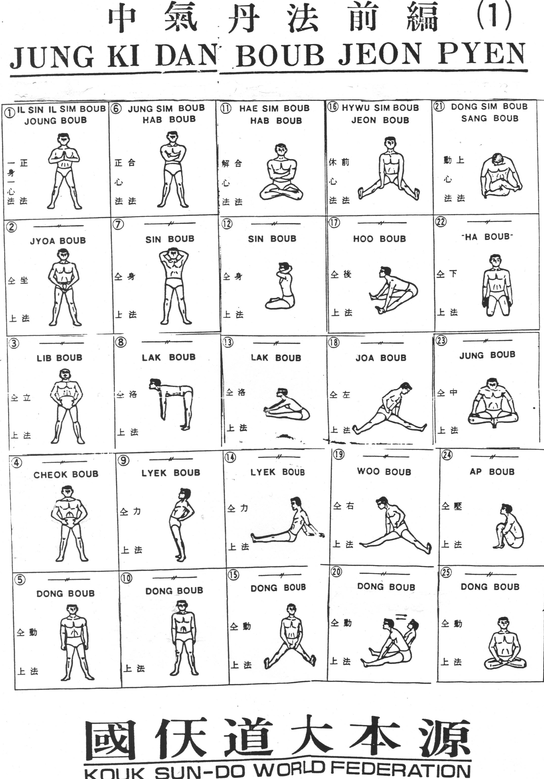
The daoist path is long and arduous and one needs to be centered and grounded while following it. Posture sets 1 and 2 play an important role in activating the Cosmological Sequence so the practitioner becomes centered and grounded.
The postures must be done in the sequence shown in order to create earth energy. The dantien breathing rhythm is maintained and unbroken throughout the sequence. One does about eight breaths in each posture. See Appendix C for posture illustrations of set 2.
My experience of the centering and grounding process via earth energy was gradual but strong. There was nothing noticeable for the first 5 or 6 months. Gradually I became aware that I was behaving differently. My thoughts, behaviors, emotions were expressed with reference to a place inside me. At first, I did not really know what or where this place was. Eventually I realized it was my lower dantien. My lower dantien began to influence everything I did and would process all my thoughts, actions, and feelings. It became a reference point for my existence. My mind continually gravitated toward the lower dantien. Sometimes I felt as if my body/mind/spirit was being absorbed into it. This absorption process helped me to develop a positive outlook toward my life. I had always been a person who saw a half glass of water as half-empty. Now I began to see it as half-full.
The centering, grounding, and positivity engendered by the combination of dantien breathing and posture sets 1 and 2 eventually had a profound impact on states of depression that I had experienced since my early twenties. My first depression occurred during my third year of college. It was a time when I had a lot of stress related to a heavy academic load, a broken relationship with my girlfriend, and the illness of my mother. I consulted the campus psychotherapist and he eventually advised me to take some time off and learn how to change my lifestyle. I followed his advice, dropped out of college for a year, moved to Boston, found another therapist (and another girlfriend), and worked my way back to health.
I graduated from college, but the depressions kept coming back. Every 4 or 5 years, I would descend into a depressed state of mind. Some were very severe and it did not matter if my life circumstances were good or bad. I realized that, in addition to my environment, there was also something in my body that triggered my mental states. I tried different forms of psychotherapy, antidepressants, and, one time, just waited for the depression to pass. They all worked to a degree and I always felt better after 3 or 4 months. But even after I felt better, there was a dark cloud that hung over my head. It was always there and I always had a feeling that it could descend at any time. The cloud was there when I began practicing Sundo.
After 22 months of daily Sundo practice, the cloud actually went away. The only explanation I have for why this happened is because I was filling my body/mind/spirit with earth qi. I was not doing any forms of therapy. The centering, grounding, and positivity of earth qi was reaching deep into me. During my 24 years of practicing Sundo, the cloud has never returned and I have not experienced any depressions.
Becoming a Sundo teacher requires getting through 33 sets of postures. Sometimes the postures are very challenging to the point of causing pain. Most of us try to avoid physical and psychological pain in our lives. Extreme physical fitness regimens which espouse "no pain, no gain" can be destructive and miss the point about balanced health and well-being. We avoid painful psychological experiences in hope of attaining happiness. Generally we think pain is not a good thing, which, in many cases is true. For example, physical and psychological pain caused by diseases has a strong detrimental effect on our lives.
Some forms of pain, however, can help us. The seeds of growth often lie in pain and suffering. My teacher, Hyunmoon Kim, often said that difficult postures teach us how to embrace pain. If we always try to rid ourselves of pain, he said, we become isolated and separated from the universe. Pain helps you to look in places inside yourself where you have not looked before. Conscious evolution and enlightenment do not come easily. There is always pain when consciousness expands. Difficult postures properly integrated into dantien breathing manufacture pain that is not harmful. It is pain that brings up deep issues so one can resolve them in order to have an authentic life.
Nevertheless, I found it difficult when I encountered pain in my practice. I did not want to experience it and preferred to avoid it. It was my lower dantien, again, that began to change my relationship to pain. I began receiving messages from my lower dantien encouraging me to “be” with pain. These messages were not ideas, but energetic urges to “try out” pain. I began doing this while practicing and in my daily life. As my body/mind became more centered in my lower dantien I was able to let pain come into me and then wait for something to happen. I moved past my limits to encounter, understand, and be with pain. My fear of it lessened and I stopped running away from it.
I began to understand that if I let the pain have me it would run its course and go away. It did not injure me so I did not have to fight against it. When I stopped fighting pain I saw deeper into myself. I realized the self I was protecting by fighting pain was not authentic. There was a greater self that accepted pain and I wanted to find it and be it. Pain was an important factor in helping me to give up a self called Ron and to begin expanding into the universe in hope of being something more.
During the first six years of Sundo practice I continued to have experiences that changed my body/mind/spirit. I could feel qi coming into my body, especially into my lower dantien. Sometimes my lower dantien would spontaneously start vibrating. These vibrations occurred mostly while engaged in practice, but a few times during normal daily life. Once, while working as a high school teacher, I was sitting in the teacher's room reading a book during my free period. Suddenly my lower abdomen began to shake violently, my body straightened, and a surge of energy made me leap out of my chair. I did not try to explain what happened to the other teachers. What could I say? I bowed my head and humbly walked out of the room.
I would like to recall two experiences that showed me the power of the practice. The first began four years before I started Sundo, while I was still doing martial arts. During a sparring match with old wooden swords, a sliver of wood pierced my left hand near the thumb. I pulled the sliver out and my hand began to bleed heavily. I washed it out and held a cloth over it until the bleeding stopped. I spread the gash open with my fingers and did not see any remains of the sliver. I did not know that a second sliver had gone very deep and my flesh had folded over it so it could not be seen. I put antiseptic on the cut and bandaged it. The cut healed in about three weeks but the area of my hand always appeared puffy. It usually did not bother me. However, when I would swing a sword for long periods of time it would ache.
When I was practicing the third set of Sundo postures, a tiny pimple appeared on my hand where the gash had occurred. After a week, the pimple changed into a small head of pus. After another week the head of pus grew larger. Eventually I began squeezing and draining the pus during my morning shower. By the next morning, the head of pus would reform. One morning, as I squeezed, a sliver of wood emerged from my hand. I could not believe my eyes. Putting qi into my body had moved the sliver toward the surface and it came out. Qi had a powerful physical effect on my body.
The second powerful experience happened when I was practicing the fifth set of postures. I had just begun my daily sitting meditation, following a period of pulling qi into my body with breathing meditation. I was sitting quietly with my eyes closed when I felt a vibration to my left. The vibration got stronger and then I felt a wave of energy moving toward me in a zigzag path. An old woman appeared in front of me, looked straight at me, and sent a pulse of energy into me. I wanted to open my eyes but could not. One hundred percent of my attention was on her and I could do nothing else. After about 10 seconds, she took a zigzag path back to the left where she had come from. I still could not move. I did not know what had happened and I was trying to process it. Eventually I realized it was contact with a spirit from another dimension. The connection went so deep inside me that I felt I had been struck by lightning.
I described this experience to a few people. Some said I simply had a hallucination. I did not think so because of the energy I felt pushing against my left side when she approached and the pulse of energy she sent into me. My teacher thought it was my own spirit/energy from a past life. I still do not have any words to describe it accurately but the impact it had is still with me. It left me with the experience of connecting to and taking energy from a spiritual being. Since those few seconds I have continued to feel connected to something greater in the cosmos. This experience inspired me to keep practicing during times when I felt I could not. I kept going because I felt the influence of something greater on my life.
During the first 6 years, I was encouraged to become a healer. I decided to learn acupressure and enrolled in a program. Acupressure is an Asian form of bodywork that uses the same acu-points as acupuncture. Instead of inserting needles, pressure is applied to points using the thumbs or fingers in order to remove energy blockages and restore proper qi flow to the body. Acupressure has been used for a wide variety of ailments including reducing blood pressure, regulating the menstrual cycle, treating anxiety, headaches, and insomnia. It is especially effective for back problems. I received certification from the American Organization of Bodywork Therapies of Asia (AOBTA) and treated many people. I discovered that dantien cultivation through my Sundo practice improved my acupressure skill. When I focused my mind on the lower dantien I could interact with the client's qi and intuitively sense where the energy blockage was located. Then I would select the proper points to move the qi. My lower dantien became a significant addition to my acupressure skills.
During my practice of the third set of postures, I was taught an additional technique for pulling qi into my body. While the breathing described above is the primary way to pull qi in and put it into the lower dantien, a specific visualization integrated into the breath can be used to pull in yin and yang qi. Yin qi is primarily found in the earth beneath us. Yang qi is primarily found in the cosmos above. There is an old daoist saying that human beings exist 'between heaven and earth'. The words heaven and earth have a unique meanings in this saying. Heaven simply refers to the cosmos or universe. It does not have any religious connotation. Earth refers to the yin energy within the earth itself – a somewhat different meaning from the above description of earth energy as centering/grounding energy (see pp. 35-37). However, when one actually experiences earth energy, it has the yin characteristic of stillness described above (see pp. 34-35) as well as centering/grounding qualities.
Human beings are formed from earth (yin) and heaven (yang) energies. There are times, during practice, when it is important to pull both yin and yang qi into the body and mix them together. This is accomplished by integrating a visualization into the breath inhale. During the inhale, the practitioner visualizes yin energy coming up from earth and yang energy coming down from heaven. Both are spiraled into the lower dantien.
Figure 3-2. Absorbing Energy From Heaven and Earth
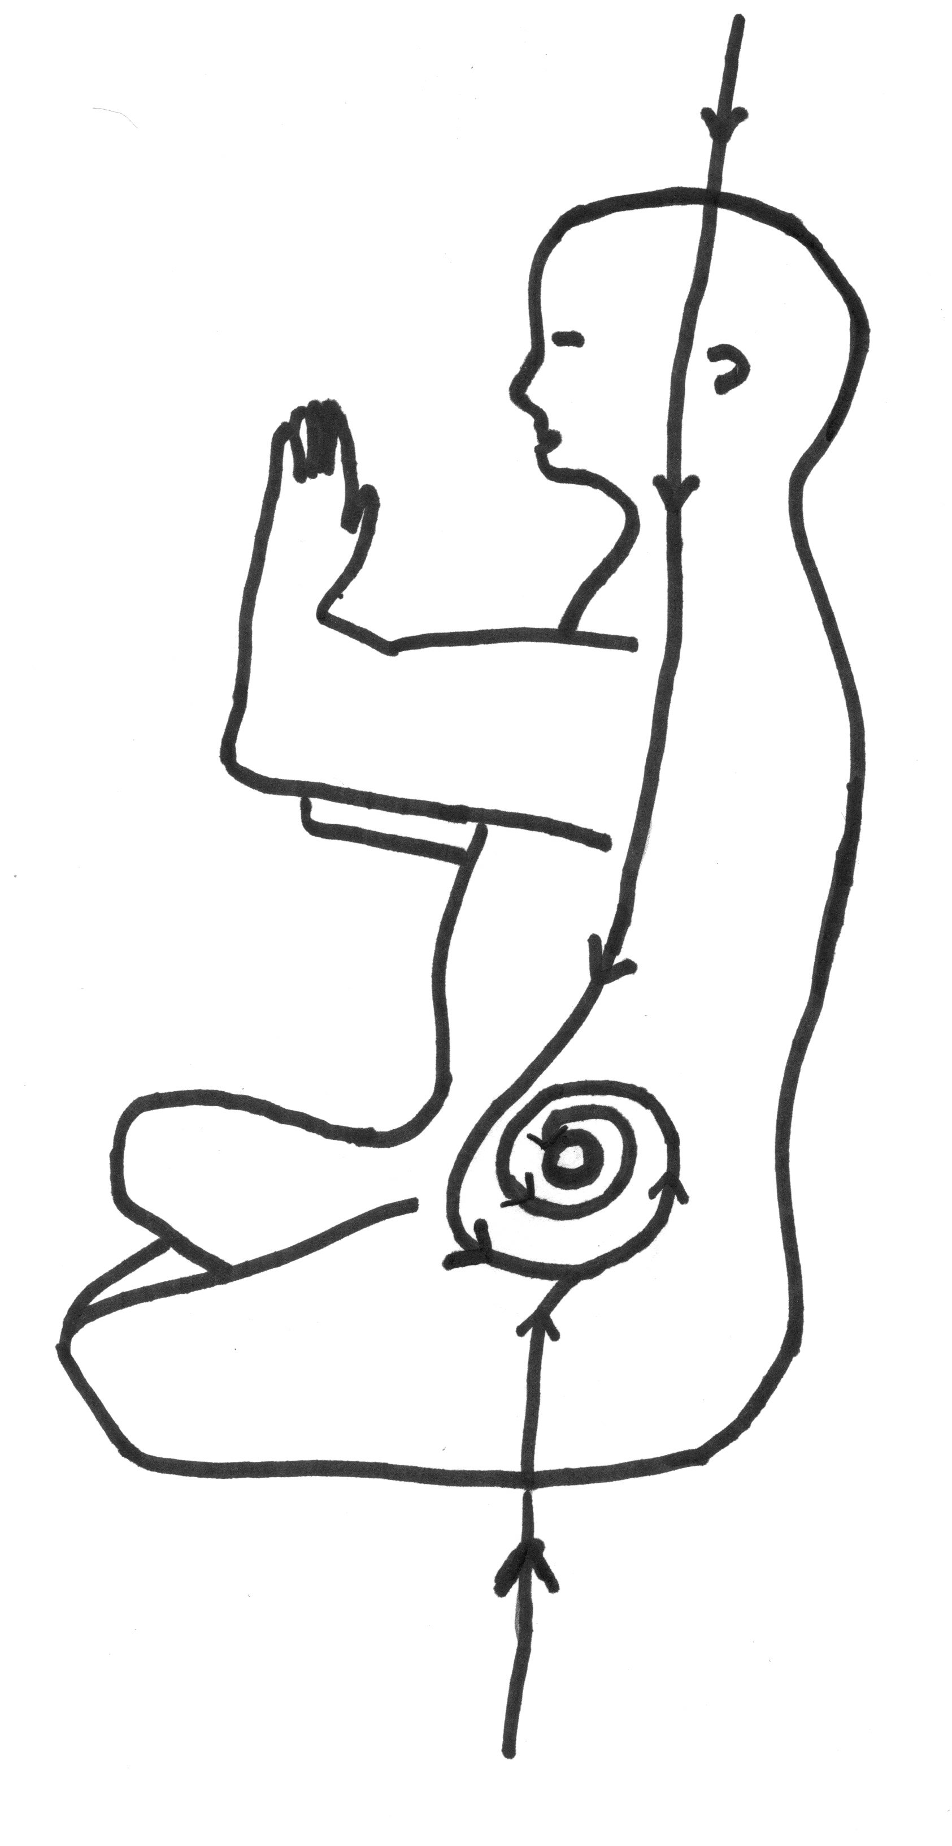
I found this technique to be very powerful in my personal Sundo practice. The main factor for making it work is uniting the visualization with the inhale. This is difficult and took me a long time to actually do it. Even when it is explained to you many times, you have to practice many months, and sometimes a few years, to actually experience the unification of visualization and breath. When the breath takes on the qualities of simultaneously being soft, slow, strong, even, smooth, and quiet (as if you are not breathing), then it pulls the visualization into it and yin and yang qi are absorbed into the body/mind/spirit.
During this phase of my practice, I lost the feeling of separation between my mind and body. My mind and body were beginning a process of unification but I was not consciously aware of it happening. Instead, my body became involved in everything I did. When I spoke, energy from my body would become part of the words. Words I used in everyday activities had a different content to them. In my job as a teacher, I could feel energy from my body influencing the meaning of whatever I was explaining to students. I experienced a wholeness of presence that was new to me. I felt a greater exchange of energy, or qi, between the environment and myself.
During sitting meditation I became aware of brightness in my head when qi from above moved down into me. I also became conscious of light coming into my body from the earth below. My body often felt light when qi pushed up into me. I did not levitate, but I understood how it might happen one day. I felt a strong tie to energies both below and above—a tie that could not ever be severed. Heaven and earth energy influenced everything I did. A non-conceptual energy language told me what to do. It controlled and guided me. I submitted to it.
Absorbing heaven and earth qi was another step toward nonduality. More and more I felt part of everything (living and nonliving) in my environment. An I still existed, but the I was no longer Ron Catabia. The I was transforming into an energetic place in the universe. I did not know (and still do not) where this place was/is. I was/am only aware of sitting in the universe.
During this time I was taught and began practicing another technique that had a deep impact on my body/mind/spirit. It is called the microcosmic orbit and is an essential part of almost all daoist practices (see p. 18 above). It is an energy circulation which begins when qi from the lower dantien is moved down to the perineum, then to the base of the tailbone, up the center of the spine, through the brain stem, then forward through the upper part of the brain, back through the lower part of the brain, begins its descent when it has reached a point even with the backs of the ears, goes down the front of the body, and finally back to the lower dantien (circles represent dantiens in the diagram). This orbit takes place on the center line of the body and passes through all three dantiens (see Appendix D for a different path of the microcosmic orbit).
Figure 3-3. Microcosmic Orbit
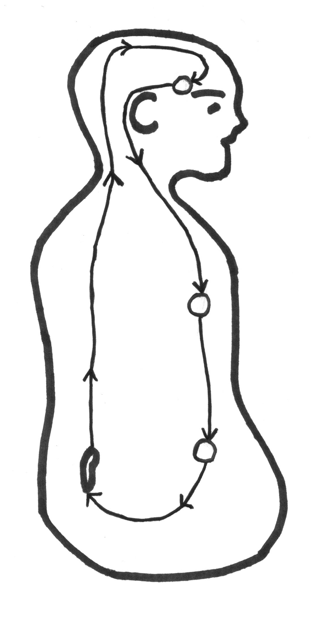
Humans are born with three dantiens, which in the Sundo model are a reflection of the human position in the cosmos. The lower dantien is related to the earth (yin qi), the upper to the cosmos (heaven; yang qi), and the middle to human spirit (shen). Sundo views humans as a microcosm of the universe. The microcosmic orbit continually nourishes all three dantiens. Nourishing the lower dantien results in physical substances (semen, egg) transforming into qi. Nourishing the upper dantien results in qi transforming into human spirit/shen. Nourishing the middle dantien results in human spirit/shen transforming into the primordial spirit of the universe (Dao). These transformations are called internal alchemy. The primordial spirit of the middle dantien eventually pulls the lower dantien up into it and the upper dantien down into it. When this happens a human being becomes one with the cosmos.
Note that the dantien cultivation sequence in Sundo is different from the dantien cultivation sequence in Chinese daoist practices as described by many contemporary scholars (e.g., Livia Kohn, Fabrizio Pregadio, Catherine Despeux, James Miller, Eva Wong). In Chinese Daoism, qi is transformed into shen in the middle dantien and shen transformed into primordial spirit in the upper dantien. Sundo internal alchemy creates dantien relationships that mirror the external world where earth is below, heaven above, and human spirit in-between.
The first few years that I practiced the microcosmic orbit seemed uneventful. Sundo uses the breath, will, and visualization to lift the energy up the spine. This takes time and patience. Again, the breath must take on the qualities of simultaneously being soft, slow, strong, even, smooth, and quiet (the same as absorbing qi, p. 44 above). The inhale also activates will. The inhale incorporates will that sends the qi up the spine—the inhale wills it up.
Eventually, the microcosmic orbit became a significant experience for me. It gave me the power and confidence to change my body/mind/spirit. I no longer felt that deep change was out of reach. I felt change was inevitable sooner or later—all I had to do was keep practicing. It even provided me with some humor. Sometimes, after lifting qi up my spine, I would see a flash of light when it entered my brain. I thought of myself as one of those cartoon characters who suddenly realizes something, which is depicted by a light bulb going off in his brain.
I also noticed a lessening of all my fears when the microcosmic orbit began to take hold in me. This was especially noticeable when taking plane trips. I had always had a strong fear of flying. As the fear of flying receded, I even began to enjoy it. I went through a period of testing my fears. I went skydiving and did fire walking. Looking back, I do not think it was necessary to do those things, but at that time they helped me to better understand myself. I think most of the fears we have in our lives can be traced down to an underlying fear of death. The microcosmic orbit gave me a sense that life and death were basically the same thing—they were different forms of an ongoing qi process. When I understood this, my fear of death also lessened.
In 1996, after 8 years of almost daily practice, I was invited to the annual Sundo spring ceremony in Seoul. Attendance at the ceremony made me a certified Sundo teacher. It was my first trip to Asia and it left a deep impression on me. In 1998, a group of Sundo practitioners, including me, helped my teacher purchase some land in northern Vermont. This land became the Sundo Retreat Center in the United States. There were 3-day retreats for Sundo practitioners at the beginning and intermediate levels. There were 10-day mountain retreats for people who wanted to gain a deeper understanding of nature in order to move to a more advanced level of practice. The mountain retreats presented another series of challenges on my Sundo path.
The winter mountain retreats were difficult. We got up at 3:00 a.m. and practiced from 3:30 to 7:30. After breakfast we practiced until lunch time. During the afternoon we worked outside, cutting firewood, repairing buildings, and shoveling snow. It snows a lot in northern Vermont. After dinner we practiced for one-hour and then went to sleep at 8:00 p.m. I slept in a small wooden-framed structure, 7 feet long and 4 feet wide. The walls and roof were made of reflective insulation material. It was located on top of a snow-covered hill. Jokingly referred to as Ron's condo, it was very cold at night. I used a sleeping bag with four thick blankets wrapped around it. Cold water training was a 15‒20 minute experience. Sleeping outside lasted for 7 hours. Sometimes I would get up before 3:00 a.m., go into the meditation hall, and sit next to the hot woodstove.
The hardship of the coldness caused more changes in my body/mind/spirit. The coldness never goes away, so my mind automatically tried to simply be with it. There is no opportunity for the mind to jump around because it has to be constantly in the present moment with the cold. My mind was focused but I was not trying to focus it. The process of natural focusing carried over into meditation practice. I stopped trying to will my mind into meditation. Meditation became more of a natural state as a result of being in the cold. Like cold water training, being out in the cold for long periods of time showed me another side of nature.
During the summer of 2002 I did a 30-day solitary retreat. The Sundo retreat center has a small yurt on top of a wooded hill that is used for solitary retreats. My plan was to stay at the yurt for 30 days and not have any human contact during that time. I arrived on a hot July day with plenty of water, a large bag of rice, canned nuts, beans, vegetables, and fruit. I had a small gas Bunsen burner which I used for cooking. Except for one change of clothes, I had nothing else. My car was parked a half-mile away in the retreat center parking area.
I barely lasted the first night. I had no plan for dealing with mosquitoes and they were overwhelming. I had heard stories about my teacher's teacher who lived in a mountain cave and how mosquitoes would not land on him. My lower dantien was pretty strong and I thought it would deter the mosquitoes. Instead, they bit me unmercifully. I did not sleep one wink the whole night. I tried meditating and they still did not let up. I put on trousers and a long-sleeved shirt but by morning my face was a total red blotch. I decided to drive into St. Johnsbury and buy some mosquito netting. I was so disappointed. My plan was to stay alone on an isolated mountain top for 30 days and on my first morning I was driving into town.
After purchasing mosquito netting, my retreat improved. I spent 8 hours every day in breathing practice and meditation. As the days went by, I noticed how attached I had become to human communication. I missed the presence of other people. I remembered stories I had read about mountain men living in the Rocky Mountains who had no human contact for years at a time. When I was not meditating or cooking, I took short hikes on nearby mountain trails. One day I encountered a deer and we looked at each other for a few minutes. I felt grateful to be in the presence of another living creature.
Although I felt lonely at times, being alone on the mountain was very beneficial. Qi coming up from the earth was very strong. Energy coming out of the trees filled my body. I felt light. I completed the retreat with an energy consciousness I never had before. The energy I absorbed from trees touched my body/mind/spirit. The trees were telling me something in a language I did not fully understand.
The trees were showing me that it is beneficial for human beings to realize nature's point of view. I remembered my teacher, Hyunmoon Kim, saying that, in nature's point of view, humans are not fundamentally different from the rest of nature. The concept of humans being apart and more highly evolved cuts us off from the universal life force. We are all one. The trees were telling me how to find my roots, how to find my place in the universe.
It is difficult to change from a human perspective to a nature/cosmological perspective. It is a sea change for the body/mind/spirit. Becoming nature's point of view is energy/qi nonduality with the cosmos. Qi is nature's point of view. I still practice to find this form of existence. My 30 days of solitary retreat were an important step toward sitting in the universe.
I lived in South Korea from 2007 to 2011. While making preparations to go, I did not think living there would affect my daoist path, but it did. I met several Sundo masters who encouraged me. It took me a few years to begin forming an in-depth understanding of Korean culture, but eventually I saw how mountain energy and spirituality/qi are deeply embedded in the Korean way of life. Korea is a very modern country, and its dedication to modern technology is in fast forward. Even though most people want a big house and a new car, they still love the qi in their mountains and often climb them to refresh themselves (Catabia, 2010). Living in Korea added a cultural dimension to my Sundo practice. I understood the Sundo/qi relationship to the Korean people.
I have been practicing Sundo for 24 years and I still discover new things about qi. When one continually works at filling and refining the body/mind/spirit with qi, then one naturally emits qi in all one’s interactions with people, animals, plants, and things. For example, if a person has a strong qi relationship with the universe and that person always tries to be truthful, then the truth the person utters will be accompanied by a strong qi flow. Any person the practitioner is interacting with will hear the speaker’s truthful words as well as simultaneously experience that person’s qi entering them. Truth has its own qi vibration pattern and when one has an abundance of qi, this vibration pattern accompanies one's words. In the dimension of vibration patterns, truth is specific qi vibration. In my own experience, I can feel a specific qi pattern/vibration go out of me when I try to be as truthful as possible. Love, courage, faithfulness, humility and other human qualities also have specific qi vibrations. Trust, in my experience, is also a component of qi and has its own vibration.
The above Review of Literature describes how we all want to be able to trust but negative life experiences have taught us to be wary. Understanding trust and mistrust are most evident when two nations negotiate with each other. The decision to trust or mistrust can, and sometimes does, lead to war. There are many good theories, rules, and procedures that all of us, from individuals to national leaders, follow in order to develop a trusting relationship. Most of these are in the form of rational models, while a few are based on intuitions and feelings. I want to suggest a method of “trust qi vibration” that goes beyond rationality, intuition, and feeling.
First of all, when one has a strong connection to qi in the cosmos, fear is reduced. Being plugged into the universe reduces fear because one understands life and death as the same qi process. A low level of fear allows the initial level of trust to be higher when we interact with one another. When there is a high initial level of trust, cooperation follows and trust is built up (Kydd, 2005, p. 183). Qi intake reduces fear and creates a mental environment conducive to trust.
Second, in my personal experience, the more trust qi vibration I send out when I decide to trust, the more the other person and I become harmonized. This harmony directs both of us toward trustworthiness. If the other person changes and decides to be untrustworthy, I can feel disharmony in his/her qi patterns. This is more than a feeling or intuition, it is how his/her qi impacts my body/mind/spirit.
Trust can be built and actualized by the same kind of qi work used in the daoist path toward nonduality. Building and creating trust is inherent in the daoist path (Sima, 2000,p. 102). When one sends qi into another person, it strikes a nerve; it sends a message that encourages him/her to trust. This is the most reliable method of trusting that I have encountered. However, it may not be practical. Cultivating qi for nonduality is a long, arduous process that many people may not want to undertake. But it is there. It is available to us if we want it.
In addition to breathing meditation, Sundo has two basic types of sitting meditation. Both are somewhat similar to the daoist meditations mentioned above in the Review of Literature: focusing on the One and sitting in oblivion (p. 19). The first form of Sundo meditation focuses the mind on a single point, the lower dantien. The second form is clearing and blanking the mind by making it still. Making the mind still means there is nothing happening inside or outside it. Stillness inside means there are no cognitive processes (thinking, rationalizing, imaging), feelings, emotions, or memories happening. There is no content whatsoever. Stillness outside means the mind does not take in any sensory stimulation. Making the mind still is similar to Zen meditation.
I practiced single-pointedness for several years and then moved on to stillness. Focusing on the lower dantien for periods of time would take my mind out into the universe. Even though the lower dantien is inside the body, it connects to the cosmos. I was connected to something larger than myself. Qi was the connecting medium. I did not think it was an experience of nonduality, but it gave me awareness of moving toward nonduality.
The practice of stillness is much more challenging. Zen practitioners like to say that stillness is not meditation—it is beyond meditation because it is nothing. There is neither an object of meditation nor a method. The body/mind/spirit is empty. They say it is just sitting and nothing else.
I like practicing stillness, but it is very difficult. It cannot be forced. If I try too hard to stop thinking, even more thoughts arise. If I resist sensory input, honking car horns sound even louder. When I have a good day and experience some quality stillness, then even my breathing and heartbeat can interfere with it. The more still I become, the more my breathing and heartbeat slow down – in these rare moments I experience deep stillness.
I discovered that stillness has a strong relationship to qi. When I am physically, mentally, and spiritually still, qi naturally flows into my body/mind/spirit. Unlike breathing meditation in which qi is directed into the lower dantien, stillness brings qi into my whole being. When my whole being is filled with qi, I see light everywhere and experience a whole connection to the cosmos. I experience a few moments of nonduality.

CHAPTER 4
SUMMARY, ANALYSIS, AND CONCLUSIONS

The experiences described in Chapter 3 are all part of the Sundo path to nonduality. These experiences gave me the strength to change myself. I acquired a new understanding of nature. Sundo nonduality is a qi experience, which is also true for most other daoist practices. Human beings are part of the qi in the universe and cannot separate themselves from it.
My experiences with the splinter in my hand, alleviation of depression, centering and grounding through earth energy, reduction of fear, and the appearance of the old woman were intended as responses to the first research question, "How does qi influence the body, mind, and spirit?"
The experiences of breath control, cultivating energy in the lower dantien, absorbing qi from heaven and earth, the microcosmic orbit, entering cold water, sleeping in the cold, and non-verbal communication with trees hopefully provided some insight into the second research question, " How does qi and dantien cultivation create a relationship between humans and nature and the cosmos?"
Finally, my learning about non-conceptual qi vibrations/patterns that underlie our personality qualities and characteristics intended to show how daoist qi cultivation can be useful for specific problems in our lives, such as making the decision to trust. All of these experiences helped me change in ways that I never thought were possible.
Sundo, and other daoist practices, activate qi. Qi makes one aware of his/her potential for change. As human beings, we all have great potential for change. But most of us do not know how to begin. Furthermore, we are often afraid to change. Yet, we must find a way because the major problems confronting humanity never seem to go away. I am writing this 8 days after 20 children (ages 5–10) and 7 adults were shot and killed in Newtown, Connecticut. Before Newtown there had already been two public shooting sprees in 2012 (the Aurora, Colorado movie theater and the Clackamas, Oregon mall shooting). Heated arguments are being put forth by both advocates of gun control and gun owners. Some form of a gun control law will probably be passed, which is a good thing. But gun control is only a superficial solution to the problem.
In a book written almost 25 years ago, Ervin Staub said, "We must identify elements of culture, institutions, and personality that reduce hostility and aggression and enhance caring connection, helpfulness, and cooperation within and between groups” (Staub, 1989, p. 6). Although Staub's book is about genocide, I think his ideas have relevance to the shooting sprees that are becoming common in the United States., especially his thoughts about connection. Staub goes on to say that the values of community, caring, and connection can supersede the need for security because humans are malleable and can change. If change is going to take place then society, in addition to offering the opportunity to fulfill basic needs, must also offer the opportunity to fulfill human potentials, including striving for spirituality and transcendence (Staub, 1989, p. 265). Many ideas are being put forth about how to solve mass shootings, but stronger connections between humans and fulfilling human potential are not among them.
In a famous quote, Leo Tolstoy said, "And yet in our world everybody thinks of changing humanity, and nobody thinks of changing himself" (Tolstoy, 1900). We always look to change something outside of us. But we need to look inward and change ourselves. Changing ourselves requires that we have an awareness of human potential. Abraham Maslow, Carl Rogers, Rollo May, Erich Fromm, Roberto Assagioli and other pioneers of Humanistic Psychology believed that human beings could expand consciousness to become aware of their full potential and then realize it. Organizations and movements developed based on developing human potential. For example, the Human Potential Movement (HPM) at Esalan Institute looked for ways to develop human potential, but only high achiever business psychology actually made use of it. The possibility of change for realizing human potential is still there but we have not yet found a reliable way to do it.
Staub's idea about connection is very important. Staub wants human beings to find a way to have a strong connection to each other. I think the idea of connection between humans has to be based primarily in nonduality. I think there is an inverse relationship between nonduality and violence. The more we can connect the less we will be violent and aggressive toward each other.
The daoist form of nonduality is experienced through qi. I think it is a powerful form of nonduality because it simultaneously affects the body, mind, and spirit. Exchanging qi with humans, animals, and plants around us creates relationships which are less aggressive and more harmonious. Qi connections with others creates a somatic awareness that we are closely linked at a fundamental level.
This somatic qi experience of connecting to each other is very deep because it arises from energy within our cells. Ki connections at the cellular level have a form of morality embedded in them. When I harm another person in any way, I injure the qi that is being exchanged between us. Consequently, I injure the qi inside me as well as the other person's qi. This is a somatic experience that is inevitable when we are energetically (qi) connected at our core level of existence. It becomes self-defeating to injure another. Qi exchange and interaction raises our awareness of the fact that we are all qi beings.
If we are going to change in ways that make stronger connections between us and help us realize human potential, then we should direct our lives toward nonduality. Daoist nonduality is a practical way to do this because qi is available to all of us. Qi is the common denominator between all human beings. If we do not look deep inside us for solutions to problems, like mass shootings, then they will continue to happen. We cannot continue to look for solutions outside ourselves. I support gun control, but it is only a stopgap solution. We need to raise our consciousness to understand that if we increase our strength of unity with other people, then we will live more in harmony with each other and help each other more. Tolstoy was right, we have to change ourselves.
Respect is another factor that needs to be looked at. Pure qi is at the core of all living things. I think we could significantly reduce the serious problems we face, such as mass shootings, if we learn how to develop respect for everything that is alive. Respect for all living things involves deep inner change.
In Western philosophy, Immanuel Kant's moral philosophy centered on respect for persons. Kant thought that a human being was an end in itself and respect is the only appropriate response to such a being (Dillon, 2010). Succeeding Western philosophers expanded his idea to include all living beings.
In Eastern philosophy, respect for all living things has always been a central tenet of Buddhism. In Daoism, respect for all living things is inherent in qi. Qi cultivation brings an awareness that life is precious, unique, and an end in itself (as Kant might say). Qi cultivation brings the experience of awe, respect, humility, and being uplifted when in the presence of any living thing. Humility is present because one feels that human beings are not necessarily the highest form of life. Qi cultivation directs one to live at the core of one's existence. When living at the core, the only appropriate response is to have respect for everything. If we could change our inner selves to do this, then many of the problems humans struggle with could be greatly reduced. Daoist qi cultivation is not a panacea, but it would make a significant difference in the way we live.
A Ming dynasty manuscript translated by Thomas Cleary says, "If people want to do the finest thing in the world, nothing compares to learning. If they want to be the best of learners, nothing compares to learning the Way [Dao]" ("Anthology on," 2000, p. 7). Learning the way involves transformation of our inner being. Transformation comes about through breath, qi, and dantien cultivation. Learning the way teaches us about our relationship to the cosmos. "Human energy is always in communion with heaven and earth in the alternation of exhalation and inhalation" ("Anthology on," 2000, p. 11). We become whole when we are always in communion with the cosmos. It is a form of wholeness where we are one with the universe. Daoist oneness, or nonduality, is a profound way to exist. Oneness brings harmony between all beings. We are clear when we have harmony, trust, and respect. Today, more than ever, we need harmony, clearness, trust, and respect for all beings.
Daoist nonduality is achieved through qi cultivation. Many qualities that we need in life, such as trust, power, and respect for all living things, are embedded in qi. We need to change ourselves and try to become like the old masters described in the Dao De Ching.
The ancient Masters were profound and subtle.
Their wisdom was unfathomable.
There is no way to describe it;
all we can describe is their appearance.

They were careful
as someone crossing an iced-over stream.
Alert as a warrior in enemy territory.
Courteous as a guest.
Fluid as melting ice.
Shapable as a block of wood.
Receptive as a valley.
Clear as a glass of water.

Do you have the patience to wait
till your mud settles and the water is clear?
Can you remain unmoving
till the right action arises by itself?

The Master doesn't seek fulfillment.
Not seeking, not expecting,
she is present, and can welcome all things.
Tao Te Ching
Verse 15
translated by Stephen Mitchell

APPENDIX A
THE FIVE PHASES SUPPORTING ENERGY SEQUENCE
THE CYCLE IN WHICH FIVE FORMS OF QI CREATE AND BUILD UP EACH OTHER

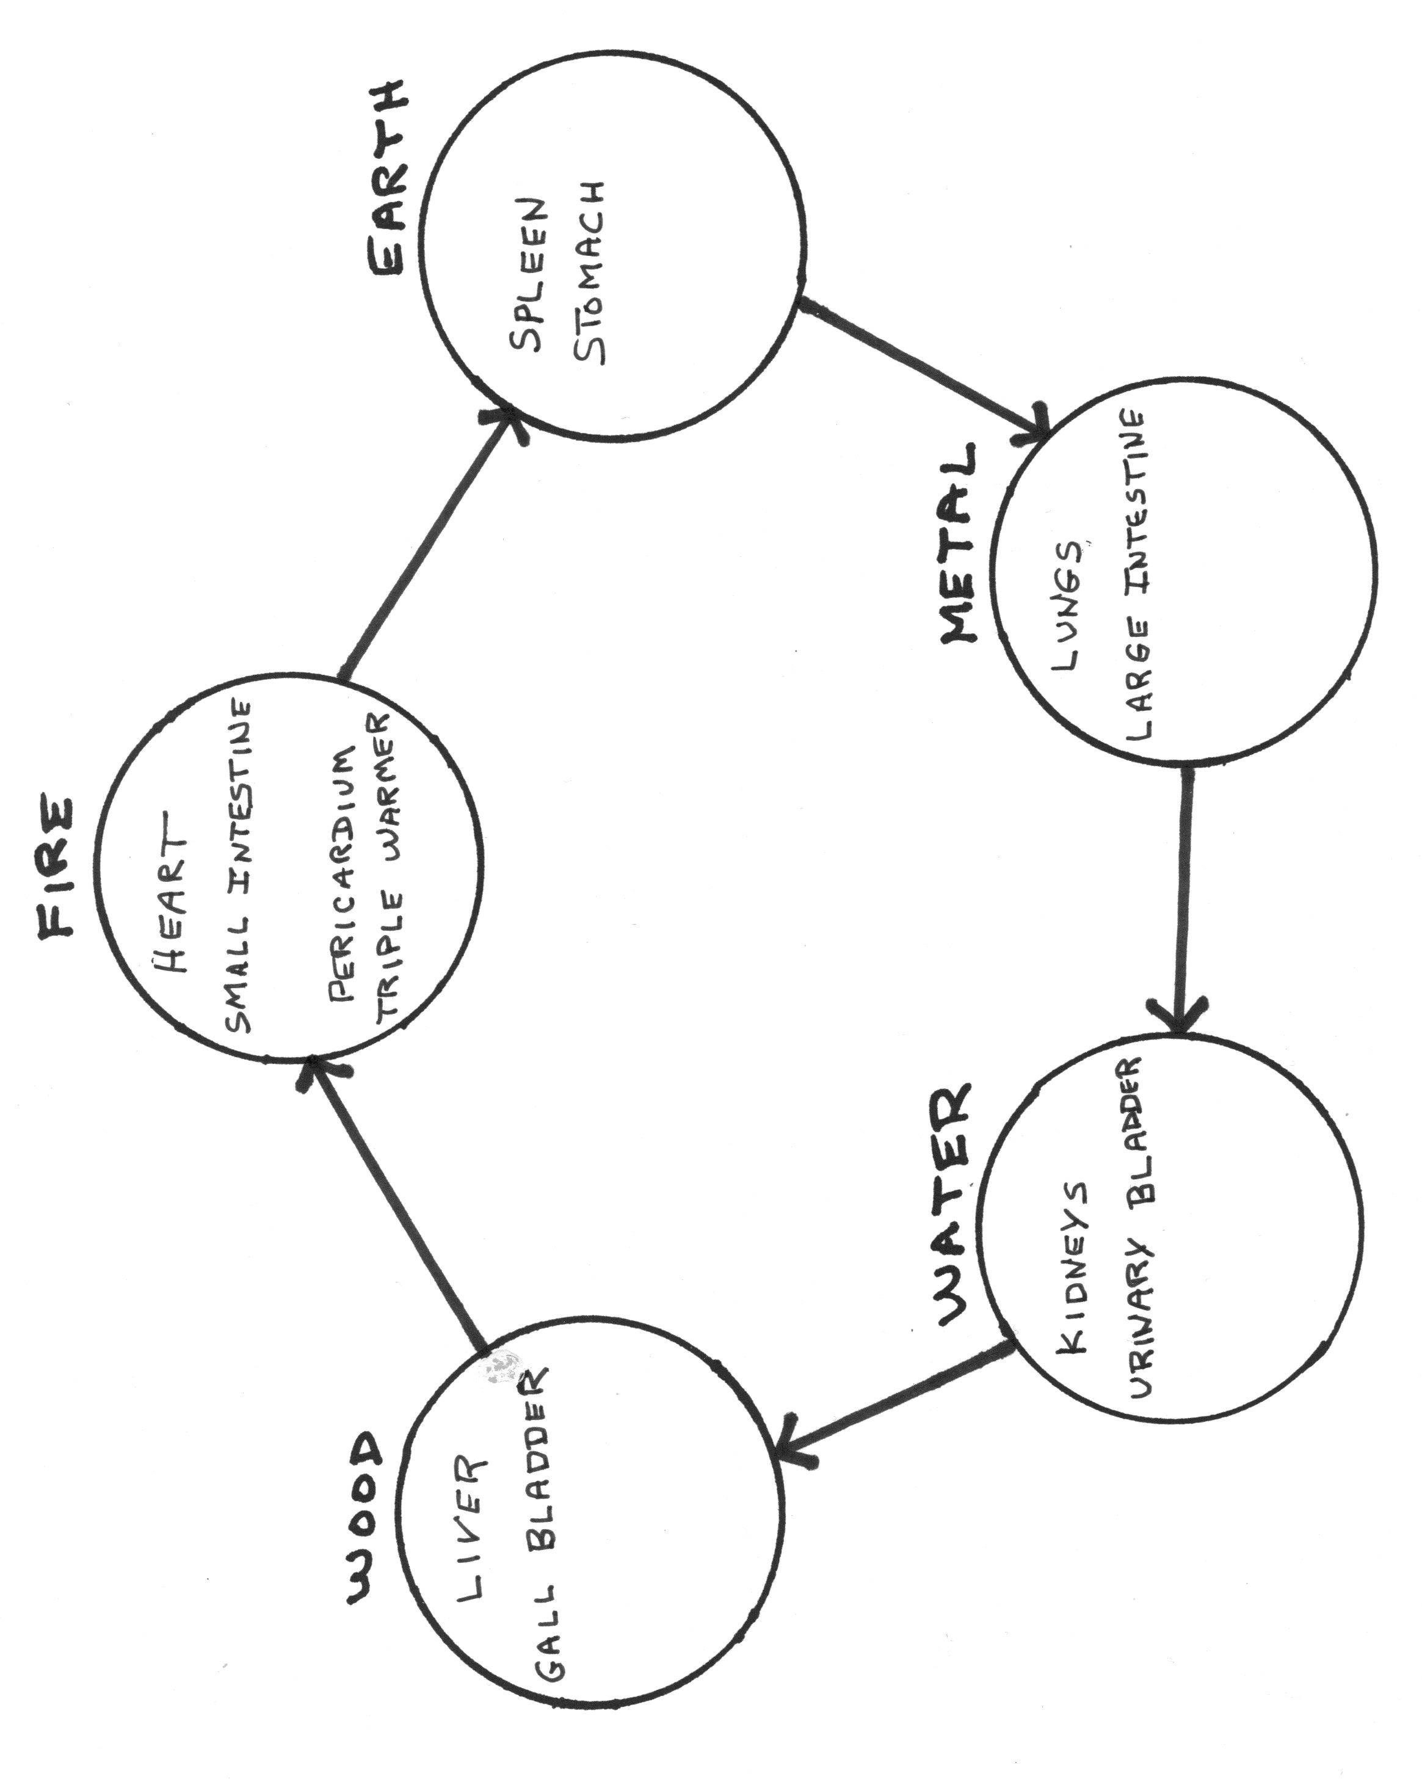

APPENDIX B
THE FIVE PHASES CONTROLLING ENERGY SEQUENCE
THE CYCLE IN WHICH FIVE FORMS OF QI CONTROL AND REDUCE EACH OTHER

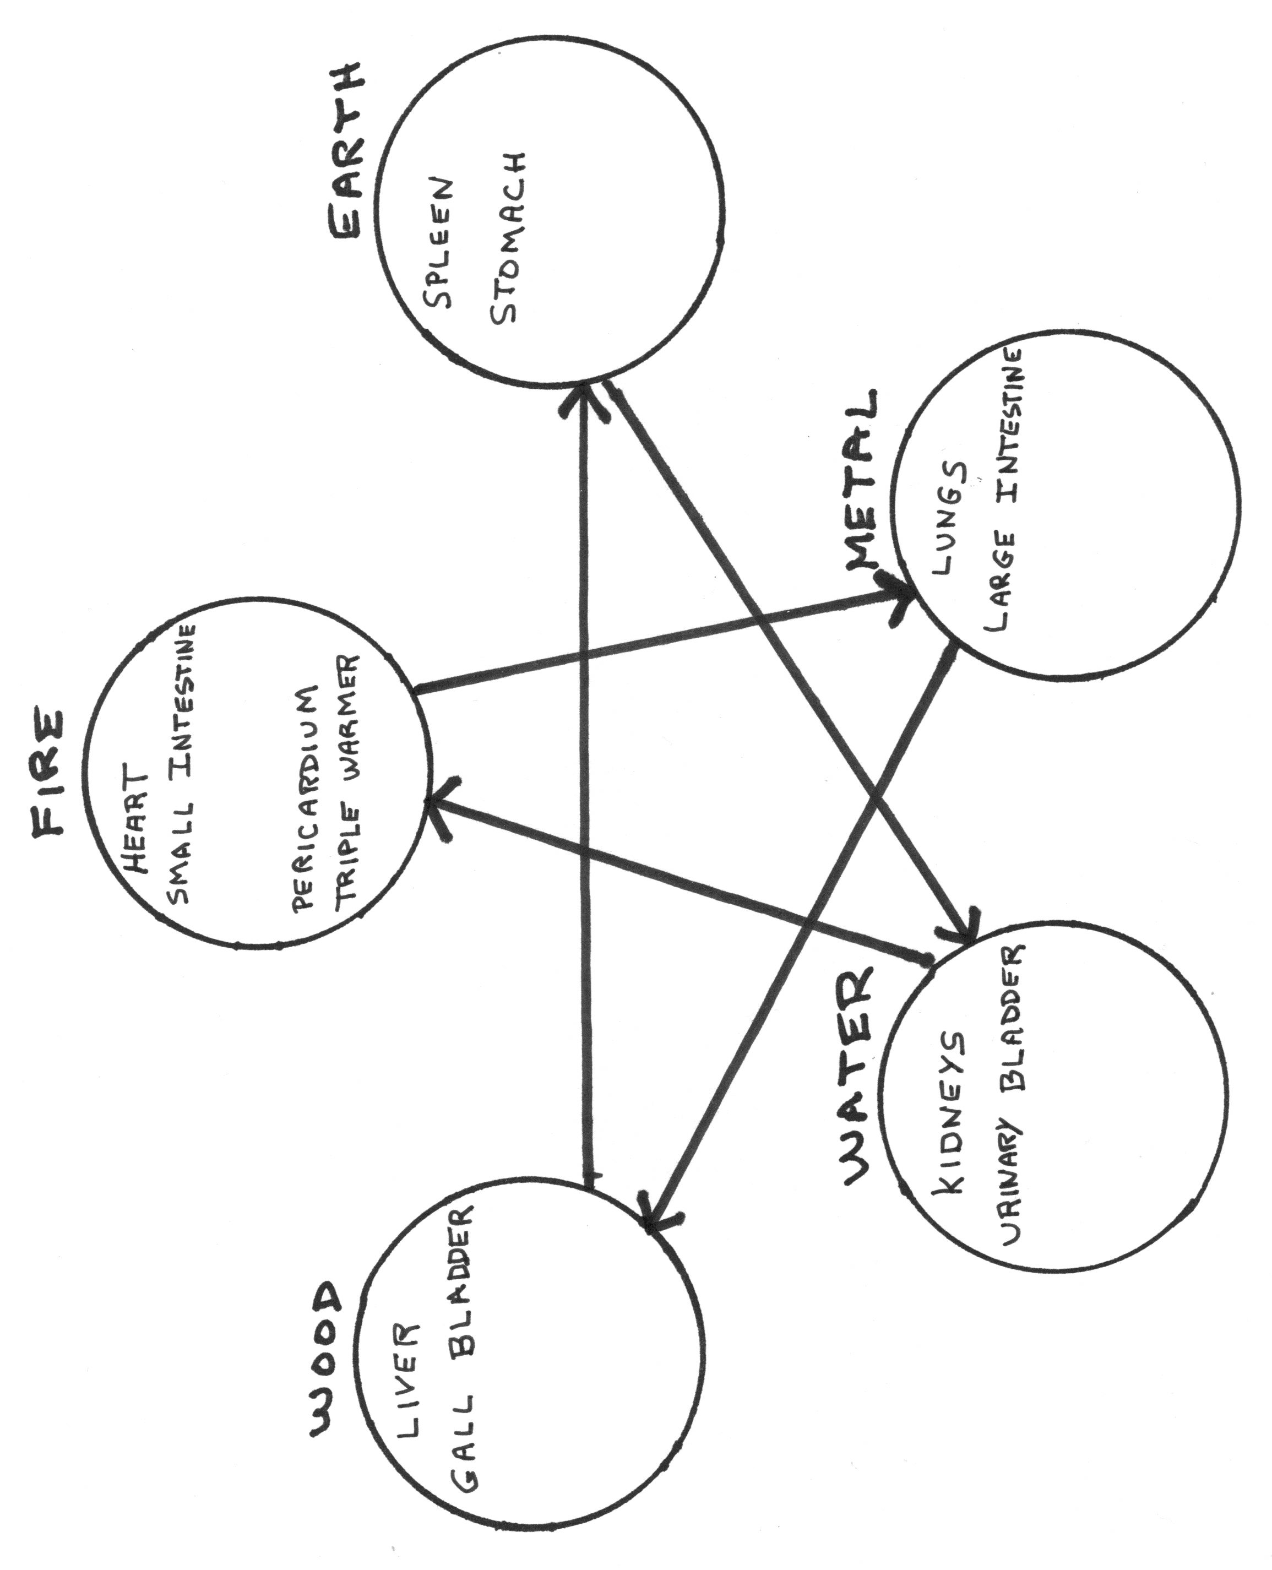

APPENDIX C

SUNDO POSTURES FOR CREATING EARTH ENERGY, SET 2

These postures continue to create Earth energy (qi) after Set 1 (p. 36 above) has been completed.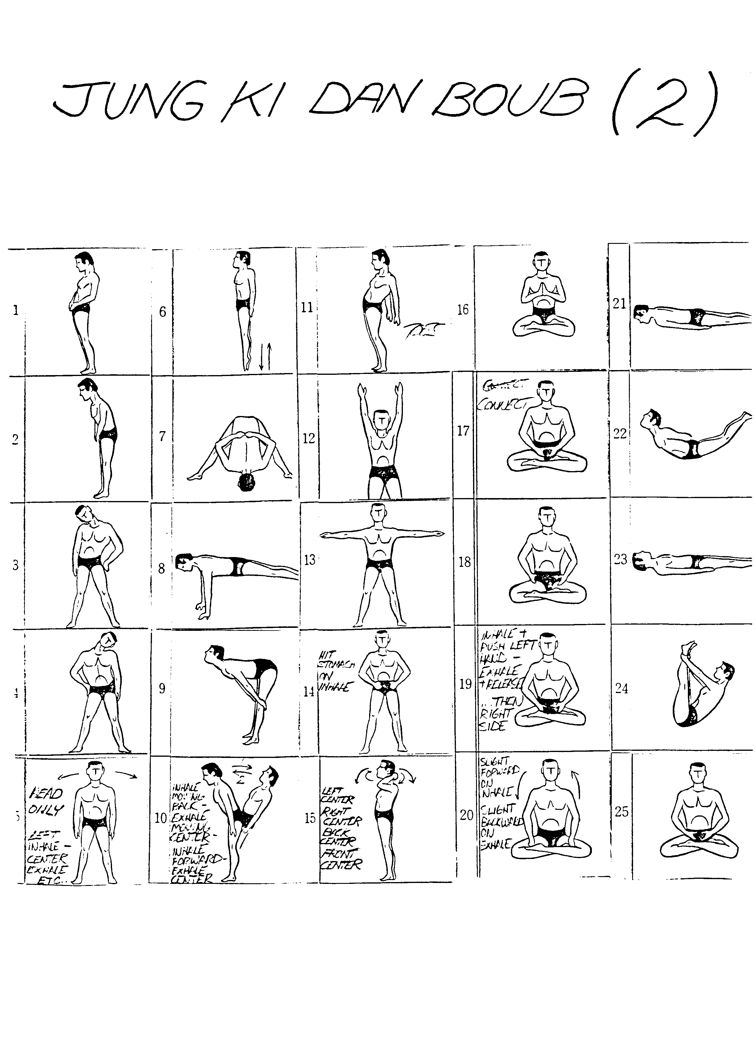

APPENDIX D

MICROCOSMIC ORBIT PATH—CHINESE DAOISM

This is the microcosmic orbit path used in most Chinese daoist practices. The Sundo path differs because it goes back through the brain and doesn't descend until it is even with the backs of the ears. (see p. 45)

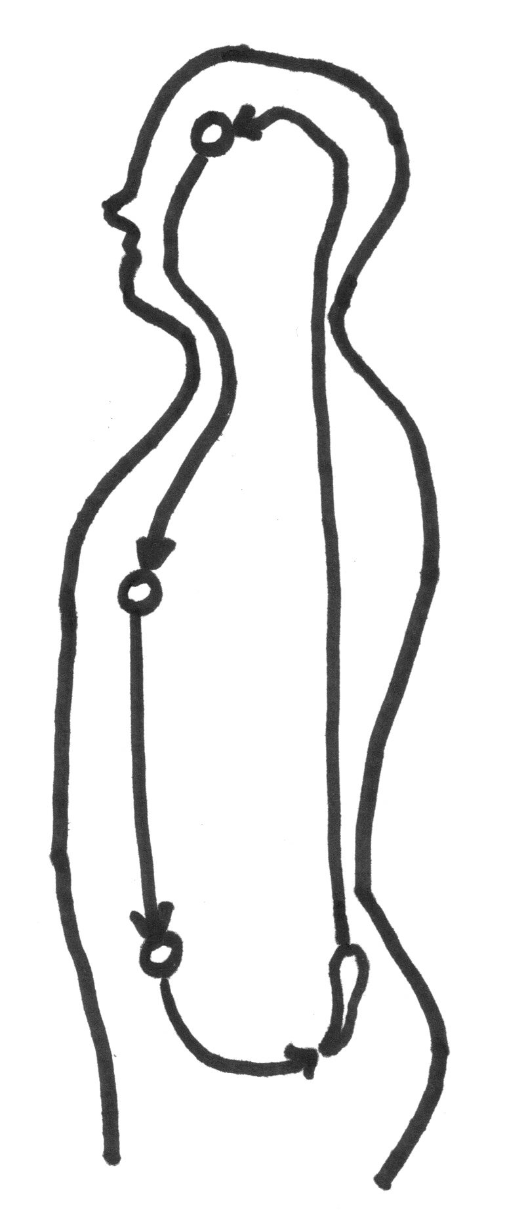
REFERENCES
Anthology on the cultivation of realization. (2000). In T. Cleary (Trans.), Taoist meditation: Methods for cultivating a healthy mind and body (pp. 7‒80). Boston: Shambhala.
Bair, P. (2009). Breathing for a better world: Final thoughts on the healing power of the breath. In S. G. Mijares (Ed.), The revelation of the breath: A tribute to its wisdom, power, and beauty (pp. 239–251). Albany, NY: State University of New York Press.
Beinfield, H., & Korngold, E. (1991). Between heaven and earth: A guide to Chinese medicine. New York: Ballantine Books.
Bibb, S., & Kourdi, J. (2004). Trust matters for organizational and personal success. New York: Palgrave Macmillan.
Blofeld, J. (1978). Taoism: The road to immortality. Boston: Shambhala Publications.
Catabia, R. (2010, Winter). Daoism in the Korean mountains. The Empty Vessel: The Journal of Daoist Philosophy and Practice, 17(2), 26‒30.
Chalmers, D. (2006). I'm conscious: He's just a zombie. In S. Blackmore (Ed.), Conversations on consciousness (pp. 36‒49). New York: Oxford University Press.
Chuang-Tzu. (2001). Chuang-Tzu: The inner chapters (A. C. Graham, Trans.). Indianapolis: Hackett Publishing Company.
Crick, F. (2006). You're just a pack of neurons. In S. Blackmore (Ed.), Conversations on consciousness (pp. 68‒78). New York: Oxford University Press.
Dalai Lama. (2005). The universe in a single atom: The convergence of science and spirituality. New York: Morgan Road Books.
Dattatreya. (n. d.). Advadhut. Retrieved from http://www.messagefrommasters.com/Mystic_Musings/Gita/avadhut_gita1.htm
Dechar, L. E. (2006). Five spirits: Alchemical acupuncture for psychological and spiritual healing. New York: Lantern Books.
Despeux, C., & Kohn, L. (2003). Women in Daoism. Cambridge, MA: Three Pines Press.
Dillon, R. S. (2010, Fall). Respect. In E. N. Zalta (Ed.), The Stanford encyclopedia of philosophy. Retrieved from http://plato.stanford.edu/entries/respect/
Flaws, B., & Lake, J. (2001). Chinese medical psychiatry: A textbook & clinical manual. Boulder, CO: Blue Poppy Press.
Gennaro, R. J. (n.d.). The nature of consciousness. Retrieved from http://www.taoiststudy.com/content/nature-consciousness-1
Goleman, D. (2007). Social intelligence: the new science of human relationships. New York: Bantam Books.
Hameroff, S. (2006). Consciousness is quantum coherence in the microtubules. In S. Blackmore (Ed.), Conversations on consciousness (pp. 115‒124). New York: Oxford University Press.
Hammer, L. (2005). Dragon rises, red bird flies: Psychology & Chinese medicine (Rev. ed.). Seattle, WA: Eastland Press.
Hollis, M. (1998). Trust within reason. New York: Cambridge University Press.
Hurley, R. F. (2012). The decision to trust how leaders create high-trust organizations. San Francisco, CA: Jossey-Bass.
Joswick, D. (n. d.). The definition of 'Shen' – Root of the spirit. Retrieved from https://www.acufinder.com/Acupuncture+Information/Detail/The+Definition+of+Shen+Root+of+the+Spirit
Jung, J.-S. (2000). Daoism in Korea. In L. Kohn (Ed.), Daoism handbook (pp. 792‒820). Boston: Brill.
Kaptchuk, T. J. (1983). The web that has no weaver: Understanding Chinese medicine. New York: Congdon & Weed.
Kim, H. (2002). The Tao of life: An investigation of Sundo Taoism's personal growth model as a process of spiritual development. Unpublished doctoral dissertation, Saybrook Graduate School and Research Center, San Francisco, CA.
Kim, H. (n.d.). Alchemy of breath: History and systems of Taoism: Sundo, a mountain taoist perspective. Unpublished booklet distributed to students by the author.
Kleeman, T. (2008). Tianshi dao. In F. Pregadio (Ed.), The encyclopedia of Taoism. (Vol. 2, pp. 981‒986). London: Routledge. Retrieved from http://www.goldenelixir.com/publications/eot_tianshi_dao.html
Kohn, L. (1993). The Taoist experience: An anthology. Albany: State University of New York Press.
Kohn, L. (Ed). (2006). Daoist body cultivation: Traditional models and contemporary practices. Magdalena, NM: Three Pines Press.
Kohn, L. (Ed). (2011). Living authentically: Daoist contributions to modern psychology. Dunedin, FL: Three Pines Press.
Kydd, A. H. (2005). Trust and mistrust in international relations. Princeton and Oxford: Princeton University Press.
Lao Tzu. (1990). Tao te ching: The classic book of integrity and the way: An entirely new translation: Based on the recently discovered Ma-Wang-Tui transcripts (V. H. Mair, Trans.). New York: Bantam Books.
Lao Tzu. (1988). Tao Te Ching: A new english version, with foreword and notes (S. Mitchell,
Trans.). New York: Harper & Row.
Loy, D. (1997). Nonduality: A study in comparative philosophy. New York: Humanity Books.
Maciocia, G. (1989). The foundations of Chinese medicine: A comprehensive text for acupuncturists and herbalists. London: Churchill Livingstone.
Maciocia, G. (1994). The practice of Chinese medicine: The treatment of diseases with acupuncture and Chinese herbs. London: Churchill Livingstone.
Manne, J. (2004). Conscious breathing: How shamanic breathwork can transform your life. Berkeley, CA: North Atlantic Books.
Mathews, A. (2011). Traversing the inner terrain: The search for the authentic self, power vs. personal empowerment. Retrieved from http://www.psychologytoday.com/blog/traversing-the-inner-terrain/201110/power-vs-personal-empowerment
McLeod, C. (20l1). Trust. In E. N. Zalta (Ed.), The Stanford encyclopedia of philosophy. Retrieved from http://plato.stanford.edu/archives/spr2011/entries/trust/
McKnight, D. H., & Chervany, N. L. (n. d.). The meanings of trust. Retrieved from http://misrc.umn.edu/wpaper/WorkingPapers/9604.pdf
McTaggart, L. (2002). The field: The quest for the secret force of the universe. New York: HarperCollins Publishers.
Mijares, S. G. (Ed). (2009). The revelation of the breath: A tribute to its wisdom, power, and beauty. Albany, NY: State University of New York Press.
Miller, J. (2003). Daoism: A short introduction. Oxford: Oneworld Publications.
Ni, M. (1995). The Yellow Emperor's classic of medicine. Boston: Shambhala.
Noyce, C. (2011). The experience of non-duality. In E. Gilbert (Ed.), Conversations on non-duality: Twenty-six awakenings (pp. 82‒93). London: Cherry Red Books.
Ohiyesa. (2007). Native American tradition: The ways of the spirit. In J. Katz (Ed.), One: Essential writings on nonduality (pp. 77‒87). Boulder, CO: Sentient Publications.
Parsons, T. (2011). The open secret. In E. Gilbert (Ed.), Conversations on non-duality: Twenty-six awakenings (pp. 94‒109). London: Cherry Red Books.
Passer, M. W., & Smith, R. E. (2004). Psychology: The science of mind and behavior (2nd ed.). New York: McGraw-Hill.
Person, E. S. (2002). Feeling strong: The achievement of authentic power. New York: HarperCollins.
Prendergast, J. J. (2007). Psychotherapy: The sacred mirror. In J. Katz (Ed.), One: Essential writings on nonduality (pp. 121‒130). Boulder, CO: Sentient Publications.
Pytlasinska, H. (2011). Non-duality. In E. Gilbert (Ed.), Conversations on non-duality: Twenty-six awakenings (pp. 70‒81). London: Cherry Red Books.
Reid, D. (1998). Harnessing the power of the universe: A complete guide to the principles and practice of chi-gung. Boston: Shambhala.
Roth, H. D. (1999). Original tao: Inward training and the foundations of taoist mysticism. New York: Columbia University Press.
Santee, R. (2011). The Zhuangzi: A holistic approach to healthcare and well-being. In L. Kohn (Ed.), Living authentically: Daoist contributions to modern psychology, (pp. 39–58). Dunedin, FL: Three Pines Press.
Schwartz, B. I. (1985). The world of thought in ancient China. Cambridge, MA: The Belknap Press of Harvard University Press.
Sima, C. (2000). Treatise on sitting forgetting. In T. Cleary (Trans.), Taoist meditation: Methods for cultivating a healthy mind and body (pp. 81‒103). Boston: Shambhala.
Solomon, R. C., & Flores, F. (2001). Building trust in business, politics, relationships, and life. New York: Oxford University Press.
Smith, H. (2007). Taoism. In H. Oldmeadow (Ed.), Light from the East: Eastern wisdom for the modern West (pp. 95‒117). Bloomington, IN: World Wisdom.
Staub, E. (1989). The roots of evil: The origins of genocide and other group violence. New York: Cambridge University Press.
Sylvester, R. (2011). I hope you die soon. In E. Gilbert (Ed.), Conversations on non-duality: Twenty-six awakenings (pp. 13‒26). London: Cherry Red Books.
Tolstoy, L. (1900). Three methods of reform. A. Maude (Trans.). Retrieved from http://en.wikiquote.org/wiki/Leo_Tolstoy
Tong, B. R. (2009). The breath of the Tao and the Tao of breathing. In S. G. Mijares (Ed.), The revelation of the breath: A tribute to its wisdom, power, and beauty (pp. 43–52). Albany, NY: State University of New York Press.
Towler, S. (1996). A gathering of cranes: Bringing the Tao to the West. Eugene, OR: Abode of the Eternal Tao.
Uslaner, E. M. (2002). The moral foundations of trust. New York: Cambridge University Press.
Wang Mu. (2011). Foundations of internal alchemy: The Taoist practice of neidan (F. Pregadio, Trans.). Mountain View, CA: Golden Elixir Press.
Wiseman, N., & Feng Ye (1998). A practical dictionary of Chinese medicine (2nd ed.). Brookline, MA: Paradigm Publications.
Wong, E. (1997). The Shambhala guide to Taoism. Boston: Shambhala.
Zhang, Y.-H., & Rose, K. (2001). A brief history of qi. Brookline, MA: Paradigm Publications.

